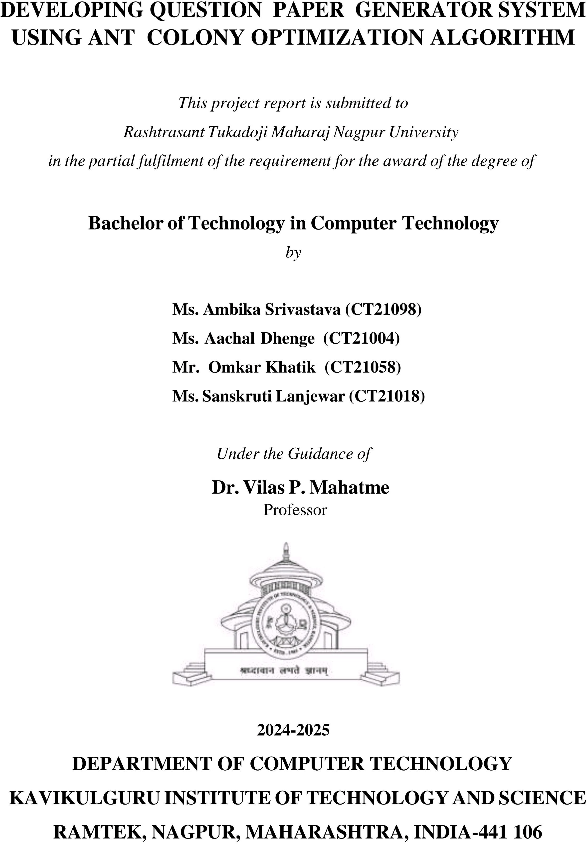

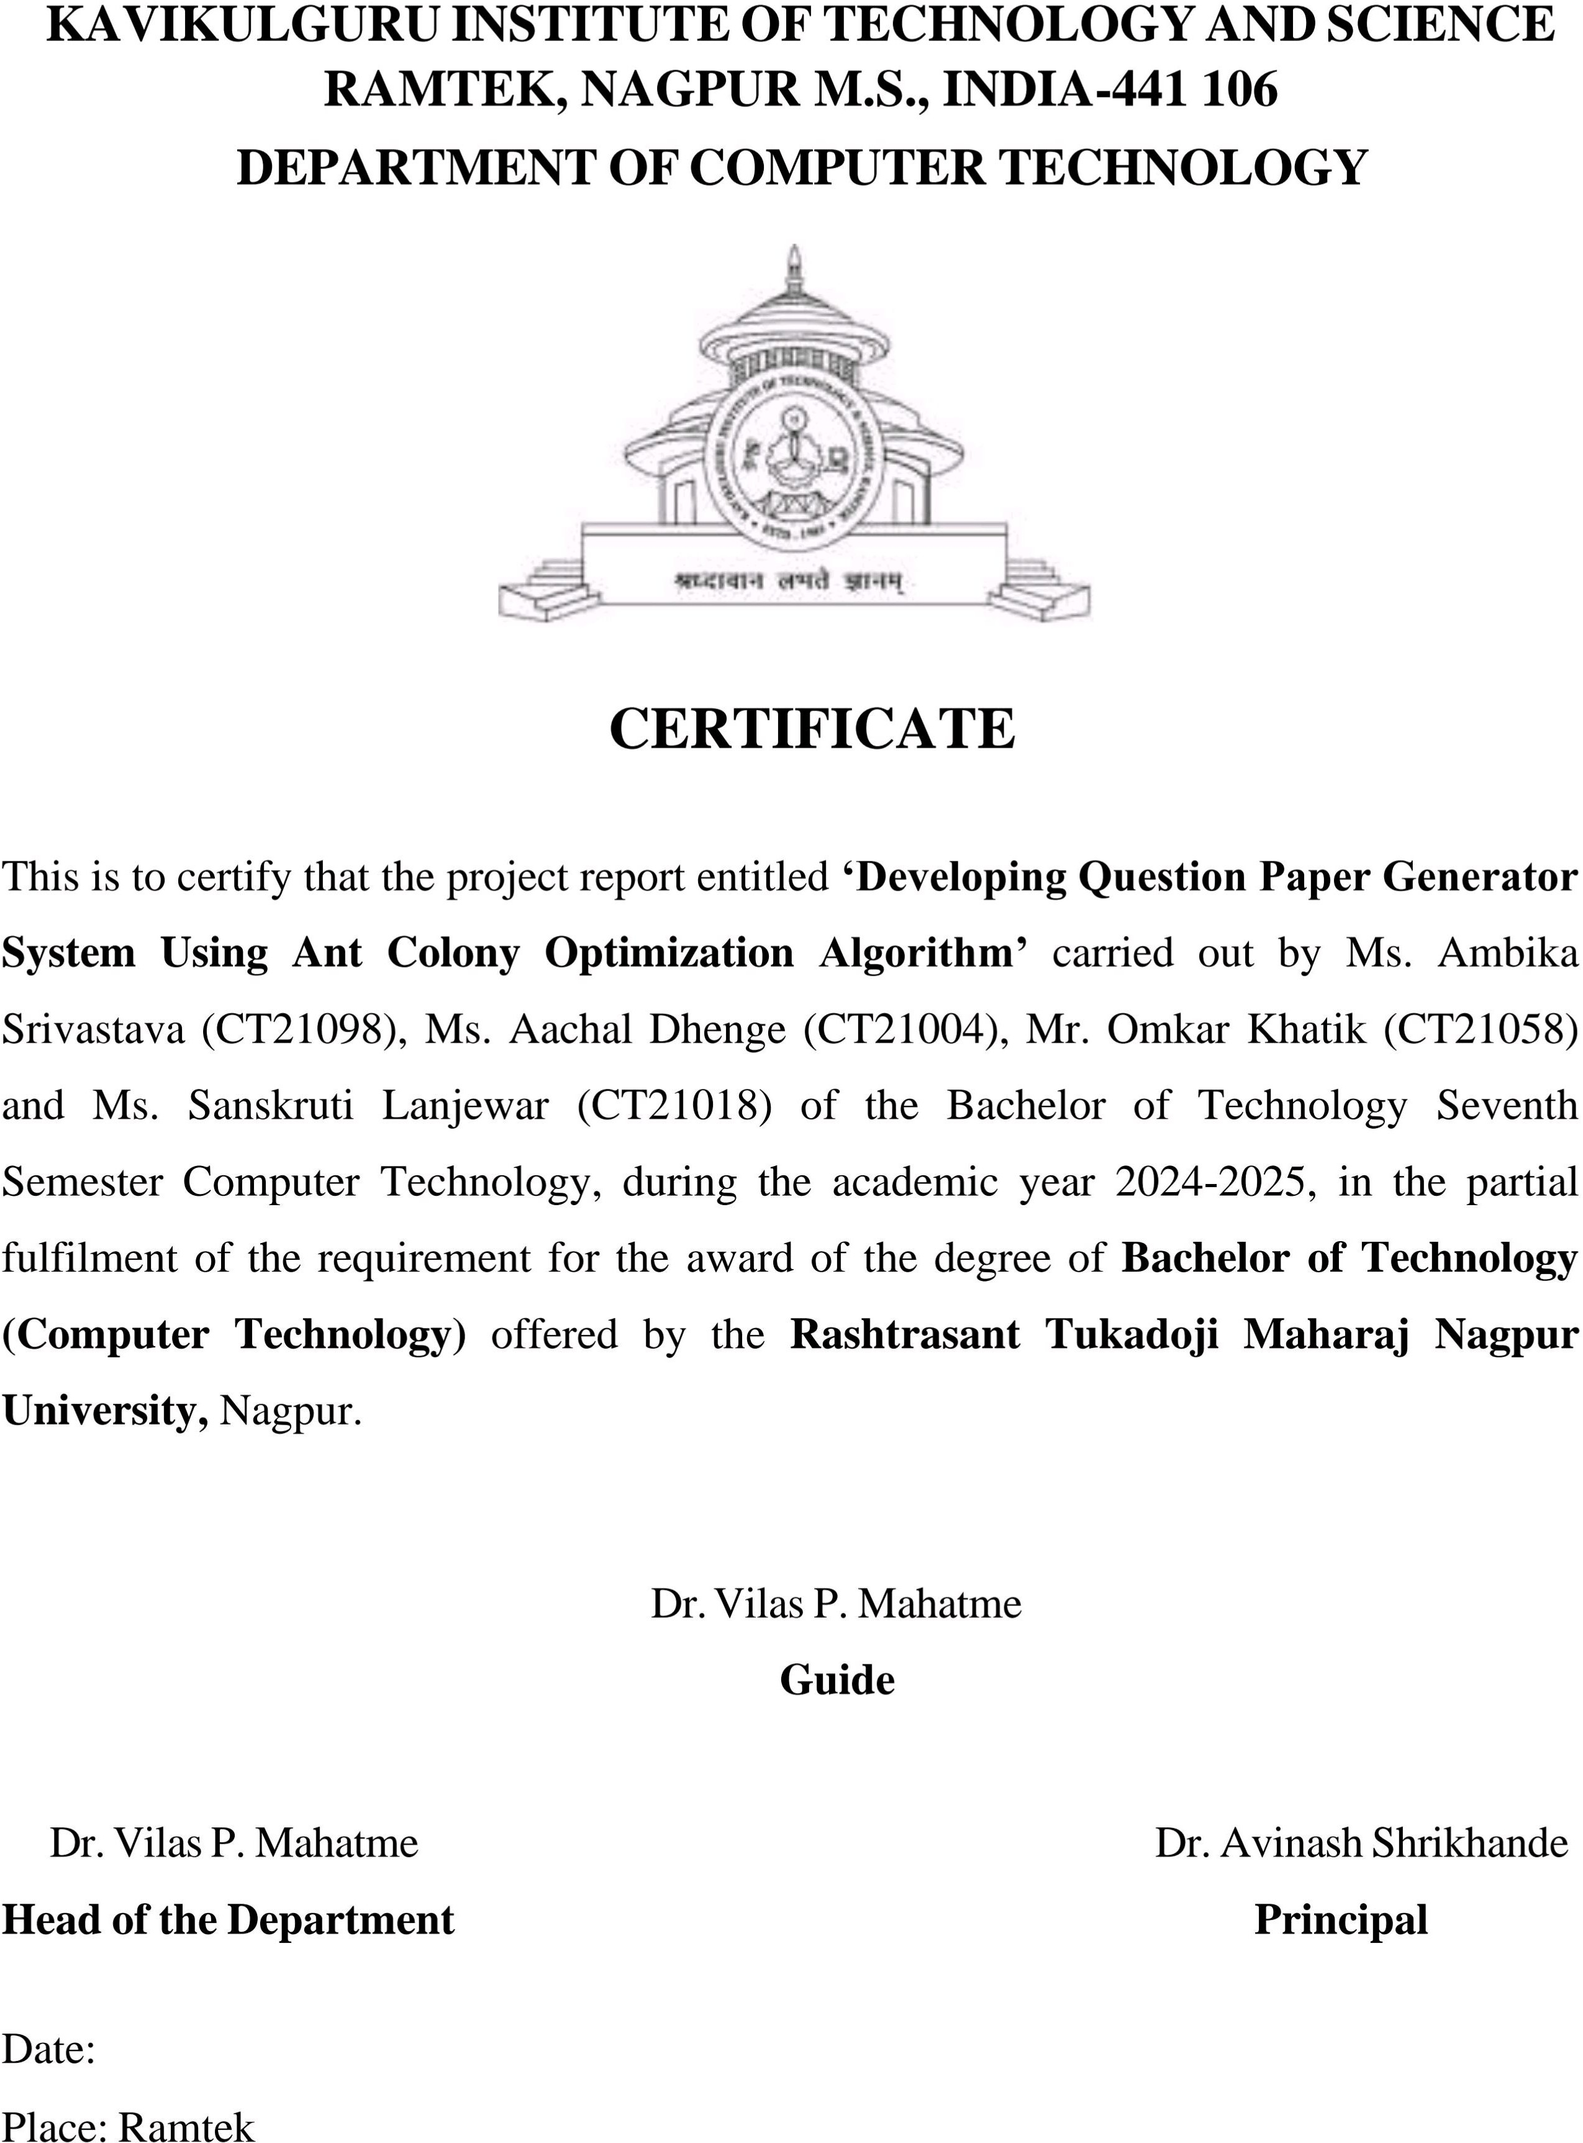



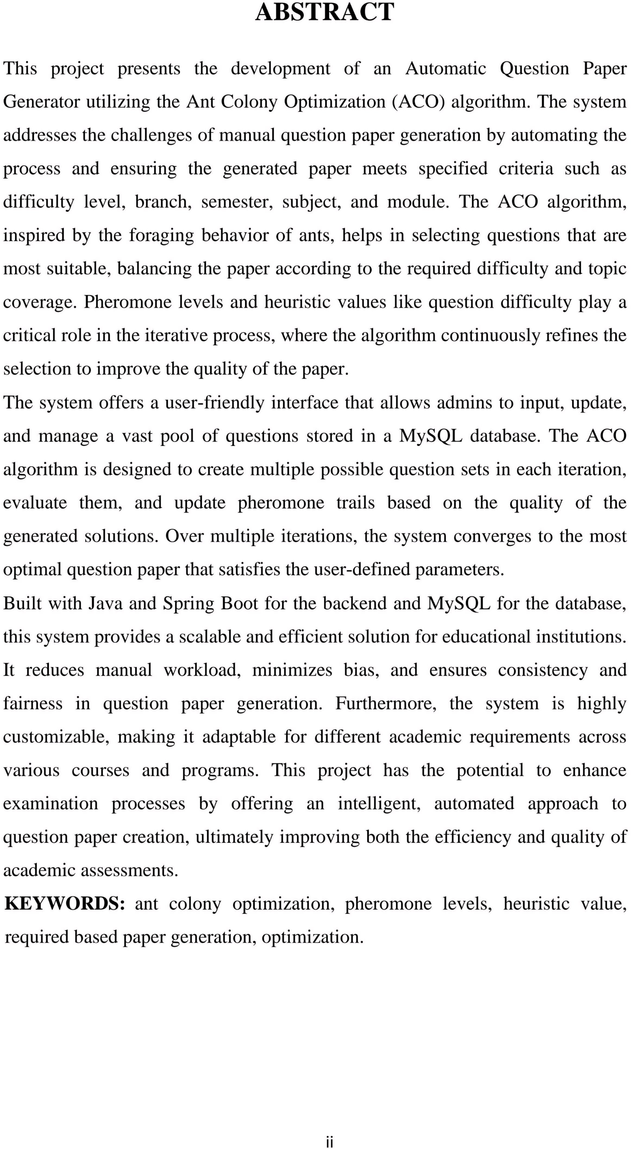

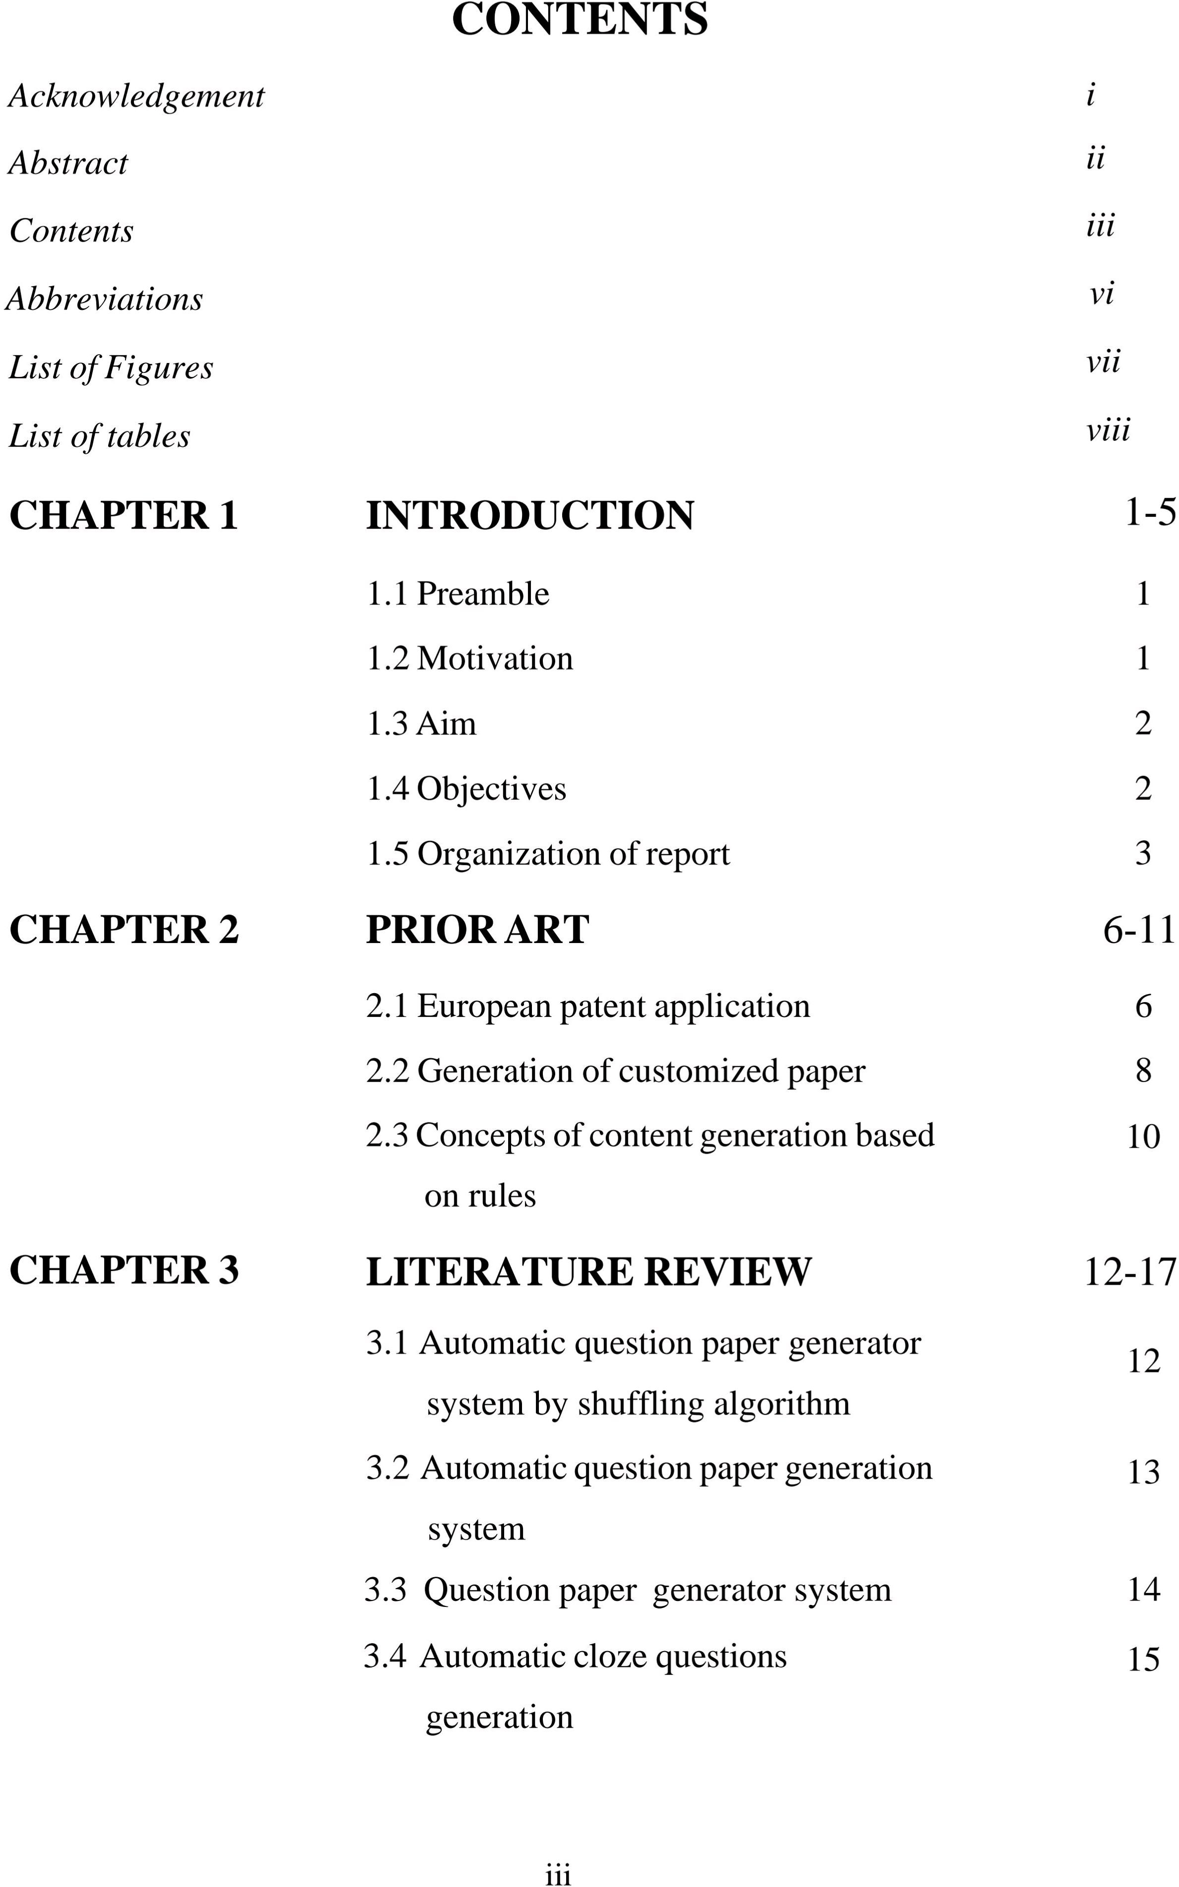

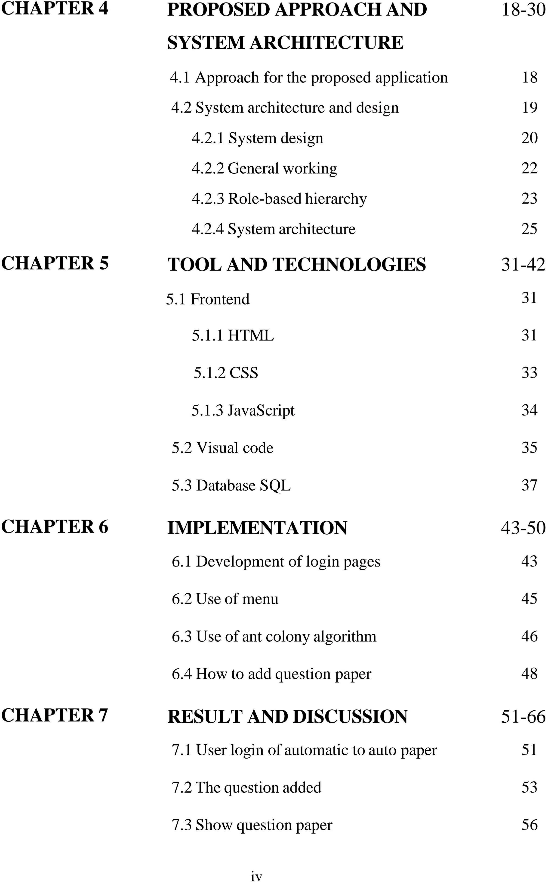



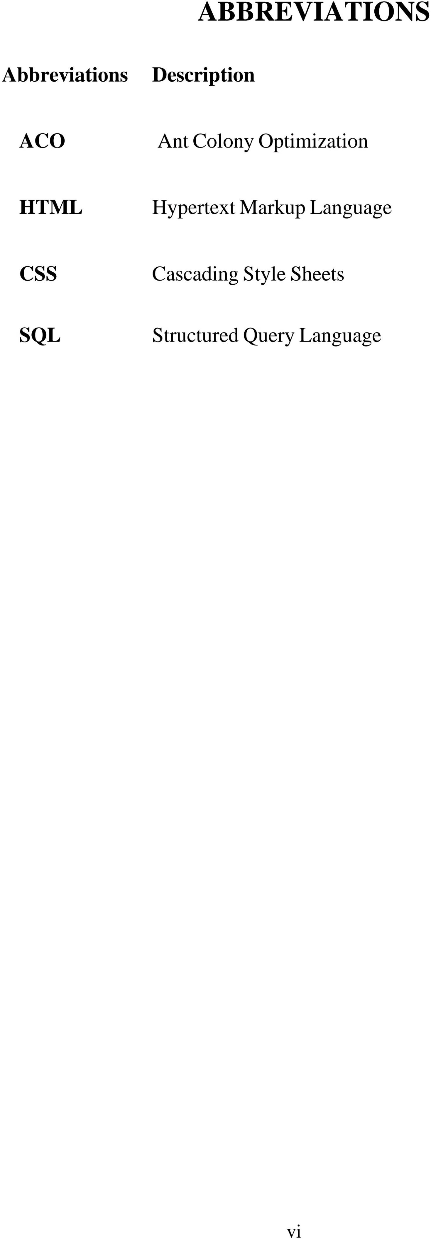

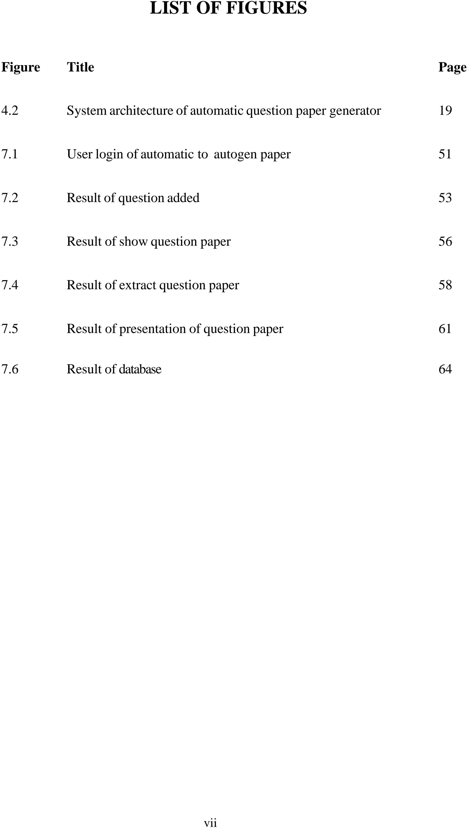

|  |  |  |
| --- | --- | --- |
|  | **LIST OF TABLES** |  |
| **Table** | **Title** | **Page** |
| 4.2.3 | Auto-generated question Paper system’s role base hierarchy | 23 |

viii

* 1. **Preamble**

**CHAPTER 1**

# INTRODUCTION

The "Automatic Question Paper Generator System using Ant Colony Algorithm" is designed to automate the process of generating question papers by using the Ant Colony Optimization (ACO) algorithm, a powerful optimization technique inspired by the behaviour of ants. This project addresses the limitations of traditional manual question paper creation methods, which are often time-consuming and prone to bias, by providing an intelligent and adaptive system. The system generates question papers based on predefined criteria, such as difficulty level, subject, branch, and module, by selecting questions from a large database. The Ant Colony Optimization ACO algorithm helps the system optimize the selection of questions by simulating the pheromone trails left by ants in nature. As ants (or in this case, algorithms) explore potential solutions, they update pheromone levels, guiding future iterations toward more optimal solutions that meet the requirements. The proposed architecture includes key modules such as a login system for admin and users, a question addition module for the admin, and a question paper generation module that takes user inputs like difficulty level and subject. Over time, the algorithm learns from past iterations to generate better question papers that match the desired criteria. The system is scalable and adaptable, making it a practical solution for educational institutions. This project report outlines the architecture, implementation, and algorithmic details of the system, demonstrating the effectiveness of ACO in optimizing the generation process. It offers a reliable and efficient way to automate question paper creation, reducing manual effort while ensuring a balanced and requirement-based selection of questions.

## Motivation

The motivation behind developing the Automatic Question Paper Generator System using the Ant Colony Optimization (ACO) algorithm stems from the limitations of traditional, manual question paper creation. Manual methods are time-consuming, prone to human bias, and challenging to balance in terms of

difficulty levels and topic coverage. This project seeks to address these inefficiencies by automating the process, allowing for faster, more balanced, and scalable question paper generation. Using ACO, the system intelligently selects questions based on predefined parameters such as difficulty, topic diversity, and syllabus coverage, ensuring fairness and uniformity in the final papers. As educational institutions expand and course offerings increase, this approach becomes essential for managing large question banks efficiently. Furthermore, the project demonstrates the real-world applicability of bioinspired algorithms like ACO to optimize traditionally manual processes, ultimately benefiting both educators and students by reducing bias, improving paper quality, and increasing efficiency.

## Aim

* + - The Aim of “Developing Automatic Question Generation “is to design and develop an automated system for generating question papers that ensures a balanced distribution of questions based on predefined criteria such as difficulty level, topic coverage, and diversity. By leveraging the Ant Colony Optimization (ACO) algorithm, the system will intelligently optimize the selection of questions from a large database, ensuring fairness and efficiency in the question paper generation process, while minimizing human bias and reducing the time and effort required by educators.

## Objectives

* To develop an automated system that generates question papers based on predefined requirements such as difficulty levels and topic coverage.
* To implement the Ant Colony Optimization (ACO) algorithm for intelligently selecting and optimizing questions from a large database.
* To ensure balance and fairness in the question paper by distributing questions across various difficulty levels (easy, medium, hard) and covering a broad range of topics.
* To reduce human effort and bias by automating the question paper creation process, improving the objectivity of the selection process.
* To enhance efficiency and scalability, allowing the system to generate question papers quickly for different subjects, branches, and semesters with minimal manual intervention.
* To evaluate the performance of the generated question papers in terms of how well they meet the required criteria for difficulty and diversity.
* To provide a user-friendly interface that allows educators to input specific parameters for question paper generation, such as the number of questions and desired difficulty distribution.
* To allow flexibility in customizing question paper formats, such as adjusting the number of questions per difficulty level, topic focus, or type (e.g., multiple- choice, descriptive).
* To ensure the security and integrity of the question database, protecting the system from unauthorized access or misuse.

## Organization of report

This project report is organized into several chapters that provide a detailed breakdown of the Automatic Question Paper Generator System using Ant Colony Algorithm. The first chapter, Introduction, outlines the problem of manual question paper generation, emphasizing its time-consuming nature and the potential for human error Introduction, outlines the problem of manual question paper generation, emphasizing its time-consuming nature and the potential for human error. This chapter establishes the relevance of the project and its impact on streamlining the question paper generation process. The second chapter, Literature Review, provides an overview of existing research and systems related to automatic question paper generation. It discusses various techniques like genetic algorithms, particle swarm optimization, and rule-based systems, evaluating their pros and cons. It introduces the motivation behind

automating this process using the Ant Colony Optimization (ACO) algorithm, along with the project’s objectives, scope, and significance. This chapter establishes the relevance of the project and its impact on streamlining the question paper generation process. The second chapter, Literature Review, provides an overview of existing research and systems related to automatic question paper generation. It discusses various techniques like genetic algorithms, particle swarm optimization, and rule-based systems, evaluating their pros and cons. The review then focuses on bio-inspired algorithms, specifically Ant Colony Optimization (ACO), explaining its origins and its application in optimization problems. This chapter justifies the selection of Ant Colony Optimization (ACO) for this project by demonstrating its suitability for generating question papers in an efficient and balanced manner. The Proposed System Architecture is covered in the third chapter, which details the design of the system, including its key components such as the question database, Ant Colony Optimization (ACO) algorithm module, user interface, and evaluation system. A high-level explanation is provided of how these components interact, with a visual diagram illustrating the overall architecture. The workflow, from user input to the generation of the final question paper, is thoroughly explained, helping readers understand how the system functions as a cohesive unit. The fourth chapter, Methodology, outlines the steps involved in applying the Ant Colony Optimization (ACO) algorithm to optimize question selection. It explains how pheromone levels are initialized, how solutions are constructed by ants, and how pheromone updates guide future selections. The criteria for question selection, such as difficulty distribution and topic coverage, are discussed in detail. This chapter provides a clear understanding of the systematic approach taken to implement the algorithm and ensure a fair and diverse selection of questions. In the fifth chapter, Implementation the practical aspects of the project are discussed. This section explains the technical implementation of the system, including how the question database was structured, how the Ant Colony Optimization (ACO) algorithm was coded, and how the user interface allows users to specify parameters pheromone levels pheromone levels pheromone levels like subject and difficulty level. The chapter provides insights into the code used to implement key modules, such as the question repository

and pheromone updater, offering a glimpse into the technical foundation of the system. The sixth chapter, Results and Discussion, presents the outcomes of testing the system. It includes sample question papers generated by the algorithm, along with an evaluation of their quality based on difficulty, diversity, and topic coverage. A traditional manual methods, highlighting the improvements in efficiency, fairness, and speed. This chapter also discusses potential challenges and areas where the algorithm could be further optimized, offering a critical analysis of the system’s effectiveness. The seventh chapter, Conclusion and Future Work, summarizes the project’s achievements, emphasizing how the Ant Colony Optimization (ACO) algorithm successfully automated the question paper generation process. The chapter also explores potential future developments, such as expanding the system to handle more complex question types, refining the algorithm for better performance, and integrating advanced evaluation metrics. The future scope includes adding new features, such as difficulty calibration or greater customization options for users. Finally, the References section lists all the research papers, articles, and other sources consulted during the development of the project. This chapter provides proper attribution to existing work in the field of Ant Colony Optimization (ACO) and automated question paper generation, ensuring that the project is placed within the broader context of academic research. Together, these chapters create a comprehensive narrative that guides readers through the development, implementation, and evaluation of the project.

**CHAPTER 2**

# PRIOR ART

## Title: European patent application

### Patent No.: EP2575123A1

The patent EP 2575 123 005, titled "Generation of Customized Paper", represents a system or method for the automated creation of personalized exam papers. This technology is focused on generating question papers that meet specific educational or testing requirements and is highly applicable in various educational and professional settings. Below is a detailed exploration of this patent:

Customizable Paper Generation: The core functionality of the patent revolves around the ability to tailor exam papers based on certain predefined criteria. These criteria could include the subject matter, difficulty level, number of questions, and format. This allows institutions to generate exam papers that are aligned with a specific syllabus or learning objectives, ensuring each test reflects the needs of the course or student.

Dynamic Question Selection: The system is capable of selecting questions from a large question bank dynamically. Based on input parameters, such as the focus area or specific topics to be tested, the system automatically selects appropriate questions. This ensures that exams are balanced in terms of content and difficulty and can be varied to meet different testing requirements.

Personalized Exams: One of the unique features highlighted in this patent is the potential for creating personalized question papers. For example, if the exam is meant to test individuals with varying levels of knowledge or ability, the system can generate versions of the exam that are appropriate for each group or individual. This is particularly useful in adaptive learning environments where personalized testing is key to assessing student progress.

Support for Multiple Formats: The system described in the patent is not limited to generating only one type of question. It can include multiple formats, such as multiple- choice questions (MCQs), short answer questions, essays, and even questions with diagrams or multimedia components. This versatility makes it a powerful tool for institutions that need to generate comprehensive exams across different subjects.

Enhanced Security Features: Security is an integral part of this patent. The system ensures that the generated question papers are secure through encryption and password protection. Only authorized personnel have access to the question bank and the

generated papers, and any handling of the papers, such as printing or digital distribution, is closely monitored to prevent leaks or tampering.

Randomized Question Papers for Integrity: A significant feature of this patent is the ability to generate multiple versions of the same exam using a random selection of questions from the question bank. This randomization ensures that no two students get the exact same set of questions, making it difficult for students to collaborate or cheat. The randomized nature also ensures that the difficulty and topic coverage remain consistent across different versions of the exam.

Automated Exam Structure Design: The patent describes a system where the overall structure of the exam, including the number of sections, type of questions, and distribution of marks, can be predefined and automated. This ensures that each exam follows a specific pattern that is compliant with the testing standards set by the institution, removing the need for manual setup each time an exam is created.

Role-Based Access: The system allows different roles for managing the exam paper generation process. Subject experts, for example, can input questions, while exam moderators can review and approve the final question papers. Administrators have oversight over the entire process, ensuring that each exam adheres to institutional policies and is generated within the required timeframe.

Data Analytics and Reporting: A unique aspect of the system is its ability to provide data analytics on the exam generation process. For instance, administrators can track which subjects have the most delayed paper generation or which areas in the question bank need more input from subject experts. This ensures a smooth and well-coordinated exam preparation process across different departments or subject areas. Scalable for Large Institutions: The system is designed to handle the needs of large educational institutions with multiple departments and a high volume of exams. The scalable nature of the system allows for the generation of thousands of question papers quickly and efficiently, making it particularly useful for universities or testing bodies that handle large-scale exams regularly. EP 2575 123 005 presents an innovative solution for the automated and secure generation of customized exam papers. Its dynamic selection capabilities, high security, and adaptability to different exam formats make it a valuable tool for both academic and professional customization and scalability, ultimately improving the quality and integrity of the exam generation process.

## 2.2 Title: Generation of customized paper

### Patent No.: EP2575123005

In The patent EP 2575 123 005, titled "Generation of Customized Paper**"**, represents a system or method for the automated creation of personalized exam papers. This technology is focused on generating question papers that meet specific educational or testing requirements and is highly applicable in various educational and professional settings. Below is a detailed exploration of this patent:

Customizable Paper Generation: The core functionality of the patent revolves around the ability to tailor exam papers based on certain predefined criteria. These criteria could include the subject matter, difficulty level, number of questions, and format. This allows institutions to generate exam papers that are aligned with a specific syllabus or learning objectives, ensuring each test reflects the needs of the course or student.

Dynamic Question Selection: The system is capable of selecting questions from a large question bank dynamically. Based on input parameters, such as the focus area or specific topics to be tested, the system automatically selects appropriate questions. This ensures that exams are balanced in terms of content and difficulty and can be varied to meet different testing requirements.

Personalized Exams: One of the unique features highlighted in this patent is the potential for creating personalized question papers. For example, if the exam is meant to test individuals with varying levels of knowledge or ability, the system can generate versions of the exam that are appropriate for each group or individual. This is particularly useful in adaptive learning environments where personalized testing is key to assessing student progress. Automated Exam Structure Design: The patent describes a system where the overall structure of the exam, including the for manual setup each time an exam is created. institution, removing the need for manual setup each time an exam is created.

Role-Based Access: The system allows different roles for managing the exam paper generation process. Subject experts, for example, can input questions.

Support for Multiple Formats: The system described in the patent is not limited to generating only one type of question. It can include multiple formats, such as multiple-choice questions (MCQs), short answer questions, essays, and even questions with diagrams or multimedia components. This versatility makes it a powerful tool for institutions that need to generate comprehensive exams across different subjects.

Enhanced Security Features: Security is an integral part of this patent. The system ensures that the generated question papers are secure through encryption and password protection. Only authorized personnel have access to the question bank and the generated papers, and any handling of the papers, such as printing or digital distribution, is closely monitored to prevent leaks or tampering.

Randomized Question Papers for Integrity: A significant feature of this patent is the ability to generate multiple versions of the same exam using a random selection of questions from the question bank. This randomization ensures that no two students get the exact same set of questions, making it difficult for students to collaborate or cheat. The randomized nature also ensures that the difficulty and topic coverage remain consistent across different versions of the exam.

Automated Exam Structure Design: The patent describes a system where the overall structure of the exam, including the number of sections, type of questions, and distribution of marks, can be predefined and automated. This ensures that each exam follows a specific pattern that is compliant with the testing standards set by the institution, removing the need for manual setup each time an exam is created.

Role-Based Access: The system allows different roles for managing the exam paper generation process. Subject experts, for example, can input questions, while exam moderators can review and approve the final question papers. Administrators have oversight over the entire process, ensuring that each exam adheres to institutional policies and is generated within the required timeframe.

subjects have the most delayed paper generation or which areas in the question bank need more input from subject experts. This ensures a smooth and well-coordinated exam preparation process across different departments or subject areas.

Scalable for Large Institutions: The system is designed to handle the needs of large educational institutions with multiple departments and a high volume of exams. The scalable nature of the system, unique aspect of the system unique aspect of the system allows for the unique aspect of the system generation of thousands of question papers quickly and efficiently, making it particularly useful for universities or testing bodies that handle large-scale exams regularly.

## Title: Concepts of content generation based on rules

### Patent No.: EP 2575 123 004

The patent EP 2575 123 004, titled "Concepts of Content Generation Based on Rules", relates to a method for generating content automatically by using predefined rules or algorithms. This patent likely focuses on leveraging rule-based systems to create content dynamically, such as exam papers, reports, articles, or other structured documents. Here’s an expanded breakdown of the key features and concepts covered by this patent: Rule-Based Generation: The core of this patent is the concept of using rules or algorithms to generate content. These rules can be predefined to include factors like content structure, format, tone, and subject matter. The system relies on these parameters to create relevant and accurate content automatically, without human intervention.

Customizable Rules: The rules can be tailored to meet the specific needs of the user. For example, in educational settings, rules can be set to include certain subjects, difficulty levels, and question types when generating exam papers. In content creation, the rules could determine the style of writing, keyword usage, or adherence to a certain format. Data-Driven Content Creation: This patent likely allows for the integration of data inputs that guide content generation. For instance, exam papers could be generated based on student performance data, adapting the difficulty and focus of the content to match the needs of the student. Similarly, reports could be generated by pulling data from external sources and formatting it according to the rules set by the user.

Reduced Time and Resource Requirements: One of the main advantages of rule-based content and the Integration with Other Systems: Finally, the patent likely allows for integration with other software systems. For example, the content generation system could pull data from external databases, APIs, or other digital platforms to populate the content. This makes the system more versatile generation is the significant reduction in time and resources required to produce content. In traditional settings, generating large volumes of content manually can be time-consuming and error prone. By automating the process through rules, Consistency Across Generated Content: One of the benefits of using rule-based systems is the ability to ensure consistency across multiple pieces of content. Whether creating hundreds of exams or multiple pieces of content. Whether creating hundreds of exam papers or articles, the system ensures that all outputs follow the same format, structure, and quality standards, reducing the likelihood of human error.

Versatile Applications: While this patent might be applicable to exam paper generation, it has broader applications in other fields as well. For instance, it could be used in journalism for auto-generating news articles, in marketing for creating personalized content for clients, or even in legal environments for drafting documents based on legal templates and rules.

Dynamic Content Adjustments: The system described in the patent would likely allow for real-time adjustments. As new rules are added or modified, the system can.

Content Personalization: The rule-based system described in this patent could also enable the personalization of content. For example, in the case of exam papers, different. Integration with Other Systems: Finally, the patent likely allows for integration with 123 004 describes a highly adaptable and efficient system for generating content based, marketing, journalism, and legal documentation, where consistency, efficiency, and scalability.

**CHAPTER 3**

# LITERATURE REVIEW

* 1. **Question paper generator system using Randomization technique Aditya Sanjay Sendhure et al. (2022)** proposed the generation of question papers through randomization technique. This technique is used in various schools, institutes, and universities. While generating a question paper the setter has to huge issue of question selection and checking its difficulty level. The Automatic Question Paper Generator System employs a Keyword-based Shuffling Algorithm with Randomization Technique to automate the creation of unique, relevant, and balanced exam papers. At its core, the system relies on a meticulously tagged question database where each question is categorized by keywords reflecting topics, difficulty levels, and cognitive skills. When generating a paper, the algorithm first extracts these keywords, applies an intelligent shuffling mechanism to randomize question selection, and then assembles the final paper while strictly adhering to predefined constraints such as syllabus coverage, marking schemes, and difficulty distribution. The Randomization Technique ensures fairness by eliminating human bias, preventing question repetition, and guaranteeing that each generated paper is distinct yet maintains consistent academic standards. By combining structured keyword tagging with advanced randomization, the system not only streamlines the paper-setting process but also enhances the quality and reliability of assessments, making it an efficient solution for educational institutions seeking to optimize their examination processes. This paper explains ways to avoid this issue. This paper targets on restricted access to users. The question paper is generated when questions are stored inside the database. The question paper is generated when questions are stored inside the database The question paper is generated when questions are stored inside the database The question paper is generated when questions are stored inside the database The questions are sorted according to subject wise system then fetches questions from the database for particular subject and prints the required automated paper. The Keyword-based Shuffling Algorithm is the core of the system. It involves creating a question database with keyword tagging, extracting keywords from the database, applying a shuffling algorithm with randomization technique, and generating question papers based on shuffled keywords. The Randomization Technique ensures that questions are selected randomly from the database, and the order of questions and answer choices (for MCQs) is also randomized.
  2. **Automatic question paper generator system by keyword-based shuffling algorithm**. **Pranav Thigale et al. (2021)** The Automatic test paper generation selects questions from a database to create a test paper, relying on a large question pool, advanced algorithms, and careful consideration of question quality and relevance to ensure effective assessments. Previously the examination cell of the college or board needed to prepare question papers manually which was very monotonous and time-consuming. There are a few systems in today’s market that offer similar services to the proposed system. Those systems are developed by different developers with different features. In this system, we have strived to overcome the drawbacks presented in these systems such as non-portability, static databases, one-tier specifications and much more. Such as: Specific questions as per constraints given by the admin with nothing extra added in. No repetition of questions in the paper. Automatic Question Paper Generator System is an advanced solution designed to automate the process of creating examination papers by intelligently selecting questions from a database. Unlike traditional manual methods, which are time consuming and prone to inconsistencies, this system employs a keyword-based shuffling algorithm to generate well structured, randomized, and high-quality question papers efficiently. One of the major challenges in manual paper-setting is the lack of standardization, as different examiners may have varying approaches to selecting questions, leading to uneven difficulty levels or topic coverage. Additionally, manually ensuring no repetition of questions across multiple exam sets is tedious. Existing automated systems often suffer from limitations such as static databases, inflexibility in customization, and an inability to dynamically adjust question selection based on specific constraints. To address these issues, the proposed system uses a smart algorithm that relies on keyword tagging. Each question in the database is associated with metadata such as subject, topic, difficulty level (easy, medium, hard), and marks weightage. When generating a paper, the system analyzes these keywords and shuffles questions while strictly following examiner-defined constraints, such as:

• Topic-wise distribution (e.g., 30% questions from Chapter 1, 20% from Chapter 2).

• Difficulty balancing (e.g., 40% easy, 40% medium, 20% hard).

• Avoiding repetition (ensuring no duplicate questions in multiple sets).

The Automated Question Paper Generation System is built on a three-tier architecture to ensure scalability, efficiency, and maintainability .

This provides a user-friendly interface where administrators or teachers can input exam requirements such as subject, total marks, and question patterns (e.g., multiple-choice, short answer, or essay questions). This layer also allows for customization, enabling users to define constraints like difficulty distribution and syllabus coverage before generating the paper. The serves as the system's core, handling the keyword-based shuffling algorithm that intelligently filters and randomizes questions while adhering to predefined rules. This ensures balanced difficulty, avoids repetition, and meets syllabus requirements. Finally, the Database stores a structured repository of questions with efficient indexing for quick retrieval, optimizing performance even with large datasets. Key advantages of this architecture include significant time savings , reducing paper generation from hours to minutes, while maintaining consistency in difficulty and syllabus coverage . The system also supports high customization , allowing examiners to set precise rules for question selection. Additionally, its modular design makes it portable, enabling adaptation for different educational boards or institutions with minimal changes. Future enhancements could include. AI-driven question recommendations, auto-grading capabilities, and cloud-based deployment for broader accessibility. Overall, this structured approach ensures reliability, fairness, and efficiency in exam paper generation.. By automating the question paper generation process, this system ensures fair, balanced, and bias-free assessments while significantly reducing the administrative burden on educators. system to evaluate computerized question paper which is one step ahead. Vijay Krishnan Purohit, also performed to generate and manage the system on a similar line. In this system, we have strived to overcome the drawbacks presented in these systems such as non-portability, static databases, one-tier specifications and much more. Specific questions as per constraints given by the admin with nothing extra added in. No repetition of questions in the paper. Level-wise entry: we have considered three out of six constraints of Bloom’s taxonomy (remembrance, understanding and application) to evaluate students based on their knowledge, understanding and ability to apply themselves. Ability to format the pattern of the question paper as per the institute’s (admin) needs. Ability to have a paper ready at any time due to its portable nature on mobile devices.This enhances the security and uniqueness of the generated question papers. The system offers several benefits, including efficient question paper generation, reduced manual effort, increased randomness and security, improved assessment quality, enhanced scalability and flexibility this is how its works.

* 1. **Automatic cloze-questions generation.** **Surbhi Choudhary et al. (2020)** introduced The Automatic Question Paper Generator System is an intelligent software solution designed to transform the examination paper creation process through advanced automation. Automatic cloze-questions generation fundamentally changes how educational institutions prepare assessments by replacing manual compilation with a sophisticated algorithmic approach. At its heart lies a specialized database containing a vast collection of questions, each meticulously categorized using a multi-dimensional tagging system that includes subject area, specific topic, Bloom's taxonomy level, difficulty rating, and mark allocation. These metadata tags serve as the foundation for the system's intelligent selection process. When generating a question paper, the system employs a multi-stage filtering mechanism that first identifies questions matching the broad subject criteria, then progressively applies finer filters based on the examiner's specified parameters. These parameters typically include the desired distribution of questions across different syllabus sections, the preferred mix of question types (such as multiple-choice, short answer, and essay questions), and the target difficulty profile. The system's algorithm incorporates advanced techniques to ensure that while questions are randomly selected from the pool, they always adhere to the defined constraints and maintain balanced coverage of the curriculum. A critical feature of this system is its sophisticated duplication prevention mechanism, which operates at both the question level (preventing identical questions from appearing) and the conceptual level (ensuring different papers test diverse aspects of the curriculum).The system architecture is designed for both robustness and flexibility, featuring a modular design that allows for easy updates to the question database and adjustments to the selection algorithms. This design also facilitates integration with existing learning management systems and educational platforms. The user interface is engineered for simplicity, allowing educators with varying levels of technical expertise to easily specify their requirements and generate customized question papers. Administrators can define templates for different types of examinations, which the system then uses to maintain consistency across multiple examination sets. The backend processing includes quality assurance checks that verify each generated paper meets all specified criteria before finalization, with options for manual override when necessary. This automated approach offers significant advantages over traditional methods, including dramatically reduced preparation time, elimination of human bias in question selection, guaranteed adherence to syllabus requirements, and the ability to quickly generate multiple parallel papers of equivalent difficulty. Importantly, the system preserves all the essential qualities of a well-designed examination while adding the benefits of computational precision and repeatability. Educational institutions implementing this solution can expect not only operational efficiencies but also improved assessment quality and greater standardization across examination sets. The software can be used effectively to generate question papers based on the level of the examination which includes unit tests. The question paper then may be referred to a higher authority that has the final decision in these three matters restriction of paper-based systems as majority of human working method, this system agonizes due to bias. There might be few questions duplicated in most of the papers as the professor has a personal tendency towards them. So, there is no assurance of virtuous randomly generated question paper. The Automatic Question Paper Generator System represents an intelligent software solution that revolutionizes exam paper creation through advanced automation, replacing manual compilation with an efficient algorithmic approach. At its core, the system utilizes a comprehensive database of questions tagged with detailed metadata including subject, topic, cognitive level (Bloom's taxonomy), difficulty, and marks allocation. When generating papers, the system applies a sophisticated multi-stage filtering process that first identifies relevant questions before applying precise constraints such as syllabus coverage, question type distribution, and difficulty profile. The algorithm incorporates intelligent randomization to ensure diverse question selection while preventing both direct duplication and conceptual overlap across papers. Designed for flexibility and integration, the system features a modular architecture that allows seamless updates and connects with existing educational platforms. Its user-friendly interface enables educators to easily define requirements and generate customized papers, while administrators can create templates to maintain consistency across multiple exam sets. The system includes quality assurance checks to verify all generated papers meet specified criteria before finalization. This automated approach offers significant advantages including reduced preparation time, elimination of human bias, guaranteed syllabus compliance, and the ability to quickly produce multiple equivalent papers. However, the system acknowledges potential limitations of traditional manual methods where personal preferences might lead to question repetition, ensuring instead that its algorithmic approach delivers truly randomized, balanced assessments. Particularly valuable for frequent assessments like unit tests, the system maintains academic rigor while introducing efficiency, though final approval remains with authorized faculty to preserve academic oversight.

## 3.4 Automatic question paper generation system. Rohan Bhirangi et al. (2017) .

This paper describes the utilization of a randomization algorithm in an Automatic Question paper Generator System which has been implemented specially for autonomous institutes. The Automated Question Paper Generator (AQPG) system presented in this paper revolutionizes exam paper creation for autonomous institutes by employing an intelligent randomization algorithm that eliminates human bias and inefficiencies inherent in traditional manual methods. By categorizing questions through detailed metadata—including subject, topic, cognitive level, and difficulty—the system dynamically generates papers while strictly adhering to syllabus coverage, balanced difficulty distribution, and marking schemes, all within minutes rather than hours. Built on a robust three-tier architecture (presentation, application, and database layers), the AQPG ensures consistency, customization, and scalability across educational institutions. This automated approach not only streamlines administrative workload but also enhances assessment quality by producing fair, standardized exams free from repetitive or favored questions, ultimately allowing educators to focus on higher-value academic tasks while maintaining rigorous evaluation standards. Future enhancements could integrate AI-driven difficulty adaptation and cloud-based collaboration for broader institutional adoption .These generating question paper is diminished after the implementation of this advanced system and because of this advanced system there is no obligation for humans to ponder and employ time which can be utilized on some additional important duty instead of designing question paper. This paper explains the generation of question papers through randomization technique. This technique is used in various schools, institutes, and universities. While generating a question paper the setter has to huge issue of question selection and checking its difficulty level. This paper explains ways to avoid this issue. This paper targets on restricted access to users. outcome of coaching and education can be attained by performing evaluation to compute student’s intellectual levels and therefore the written exam is a method for teachers to validate student understanding and knowledge, as well as, to evaluate the degree to which students are able to adjust a learning thesis in a given environment. The Automatic Question Paper Generator System represents a sophisticated technological solution designed to revolutionize the traditional examination paper creation process. At its core, this system employs an intelligent algorithm that automates the selection and arrangement of questions from a comprehensive digital repository, effectively eliminating the inefficiencies and inconsistencies inherent in manual paper-setting methods. The system's foundation lies in its keyword-based methodology, where each question in the database is meticulously categorized and tagged with relevant metadata including subject matter, conceptual domain, cognitive difficulty level, and scoring value of text content. This advanced categorization system enables the platform to perform dynamic, criteria-based question selection with remarkable precision. When generating an examination paper, the algorithm processes multiple layers of constraints simultaneously - it ensures appropriate coverage of the prescribed syllabus, maintains a balanced distribution of question difficulty as specified by the examiner, and strictly prevents the repetition of identical or conceptually similar questions across different paper sets. The system's architecture incorporates robust validation mechanisms that continuously verify whether the emerging question paper complies with all predefined parameters before finalization. The technological framework follows a carefully designed three-layered structure that optimizes both functionality and user experience. The interface layer provides educators with intuitive controls to specify their exact requirements, including subject selection, marking scheme, and desired question distribution patterns. The processing layer houses the intelligent algorithms that perform the complex task of filtering, selecting, and sequencing questions while adhering to all specified constraints. The data layer maintains a systematically organized and easily searchable repository of examination questions, complete with comprehensive metadata for each item. What distinguishes this system from conventional approaches is its ability to combine rigorous academic standards with computational efficiency. It maintains the essential qualities of a well-constructed examination - comprehensive syllabus coverage, appropriate difficulty gradation, and academic rigor - while achieving these objectives through automated processes that require minimal human intervention. The system's design incorporates sufficient flexibility to accommodate varying examination patterns across different educational boards and institutions, making it adaptable to diverse academic contexts. By implementing such an automated solution, educational institutions can ensure the consistent quality of their assessment instruments while significantly reducing the time and effort traditionally required for paper setting. In the prevailing paper-based systems, the prevailing system for question paper creation needed human staff to chalk out questions that come in the question paper. Teachers select the questions according to the syllabus and pattern as prescribed by the college. .Restriction of paper-based systems as majority of human working method, this system agonizes due to bias. There might be few questions which are duplicated in most of question papers as the professor has a personal tendency towards them.

**CHAPTER 4**

# PROPOSED APPROACH AND SYSTEM

**ARCHITECTURE**

## Approach for proposed application

The proposed Automatic Question Paper Generator System employs a hybrid intelligent approach, combining Ant Colony Optimization (ACO) with machine learning (ML) techniques to automate and optimize exam paper creation. The system follows a modular and scalable architecture, ensuring seamless integration of components while maintaining flexibility for future enhancements. The question bank module serves as the foundation, storing categorized questions with metadata such as subject, topic, difficulty level, and question type (MCQ, descriptive, etc.). Machine learning techniques, including natural language processing (NLP) and supervised classification (via scikit-learn/TensorFlow), analyze and tag questions for improved retrieval and relevance. The ACO algorithm dynamically selects the optimal set of questions by simulating pheromone-based pathfinding, where high-quality question combinations receive stronger "pheromone trails," guiding subsequent selections toward balanced difficulty and topic coverage. The system features a user-friendly web interface (built with HTML, CSS, and JavaScript) that allows educators to configure exam parameters (e.g., subject, difficulty distribution, question types) and customize output formats (PDF/DOCX). The backend, developed using Java with Spring Boot, handles RESTful API requests, executes the ACO-based selection logic, and manages database interactions via MySQL/MongoDB. To ensure robustness, the system incorporates randomization techniques to prevent question repetition and supports multilingual question banks for diverse educational needs.

Key workflows include:

1. Question Ingestion – Admins/teachers upload and categorize questions.

2. Paper Configuration – Users define constraints (difficulty, topics, marks distribution).

3. Optimized Generation – ACO selects questions while ML ensures alignment with pedagogical goals.

4. Export & Review– Generated papers are previewed, customized (fonts, layout), and exported securely. Future enhancements may include LMS integration, AI-powered question generation, and adaptive testing features, further reducing manual effort while improving exam quality. This approach ensures efficiency, fairness, and scalability, making it a valuable tool for educational institutions .Module, Algorithm Module, User Interface Module, and Database Management System.

## System architecture and design

Our proposed system introduces an advanced web-based solution for automated examination paper creation, combining intelligent algorithms with role-based access control to streamline the entire process while ensuring academic integrity and security. User will be able to login in the web application by entering system for Automatic is a we have proposed a revised system for Automatic Examination Question Paper Generation which is devised upon the Shuffling Randomization Algorithm and Role based Hierarchy model. . 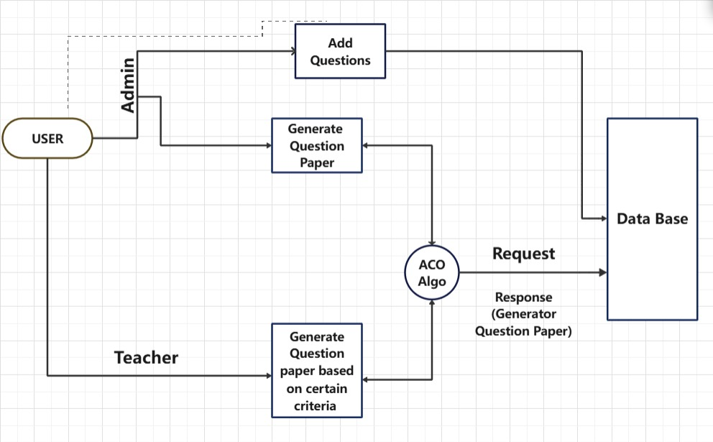

Fig4.2 System architecture of automatic question paper generator

Core System Functionality The platform operates through a three-tier architecture that efficiently manages user interactions, data processing, and secure output generation. At its foundation, a MySQL database stores all critical information including categorized questions, user credentials, and institutional syllabus patterns. The middle layer, developed in Java, handles complex operations like our enhanced Shuffling Randomization Algorithm which intelligently selects questions while preventing repetition through a sophisticated flagging mechanism. The presentation layer provides an intuitive web interface where authorized users can generate customized exam papers with just a few clicks. Our system has revised this existing algorithm by integrating an efficient question marking system in our proposed algorithm. The role-based hierarchy allows the tasks to be divided among a number of users depending upon their roles. A central administrator will have complete authority over all tasks and users. The Interface is provided using Java and MySQL database is used to store questions and related data. Syllabus and pattern of any course is considered for all questions and the subsequent generated papers. Also, the system is fully customizable according to any educational institute and course schemes. Secure Algorithms are used to store admin and user passwords to enhance security. The shuffling algorithm uses a basic randomization algorithm with a flag system used to mark selected questions. This prevents the questions from being repeated in subsequent examination papers. On generating a question paper, this paper is converted in to an encrypted pdf and can be sent over all institutions on the click of a button. A. General Working The system is entirely governed through the login screen. Here the user can login using his credentials. On successful login, various systems are available to the user depending on his/her role in the hierarchy. For e.g. The administrator has data entry options as well as paper generations option. However, the paper generator can only access the paper generation option. A data entry user (or the admin) can enter various data and customize the system according to the organization. Courses, syllabus, patterns. The system architecture of the Question Paper Generator System is designed to integrate various components that work together to automate the exam creation process. At the core, it features a centralized database that acts as the question bank, storing questions along with associated metadata such as subject, topic, difficulty level, marks, and type. The application layer houses the question selection algorithms, which interact with the question bank to retrieve questions based on user- defined parameters like topic coverage, difficulty balance, and question type. The system’s user interface layer serves as the front end, providing educators with an easy-to-use platform where they can input their criteria for the exam paper. The system incorporates several robust operational features designed to optimize the question paper generation process. At its core, the enhanced Shuffling Randomization Algorithm ensures fair and balanced question selection while preventing repetition across multiple exam papers through an intelligent flagging mechanism. The platform automatically aligns generated papers with institutional curriculum requirements through dynamic syllabus mapping, maintaining strict adherence to prescribed learning outcomes and examination patterns.

For academic precision, the system employs smart question distribution that carefully balances difficulty levels, question types, and mark allocations based on customizable parameters set by educators. Security is prioritized through automated PDF encryption, safeguarding sensitive examination materials, while comprehensive audit logging tracks all system activities for accountability and quality assurance. The system further enhances usability with real-time preview capabilities, allowing educators to review and adjust generated papers before finalization. These operational features work in concert to deliver a reliable, efficient, and secure solution for examination paper creation that meets the diverse needs of educational institutions while maintaining the highest standards of academic integrity.

System design of the Question Paper Generator System has sophisticated tool designed to streamline the process of creating exam papers, catering to various academic and institutional needs. It automates the creation of question papers based on user-defined criteria, such as the subject, difficulty level, and question type, thus saving time and ensuring consistency in exams. Question Bank Management: At the heart of the system lies the question bank, a comprehensive repository of questions categorized by subject, topic, difficulty level, marks, and type (e.g., multiple-choice, true/false, short answer, or essay). Each question is stored with metadata, including details like the correct answer, explanation (for future review), and the weightage in marks. This allows the system to easily filter and select questions during the paper generation process. The question bank also allows for manual addition , modification, and deletion of questions by authorized personnel. User Interface (UI):The user interface is designed to be user-friendly, enabling teachers or examiners to easily configure the requirements of the exam paper.

Through this interface, users can select the subject, topics to be covered, the number of questions, the type of questions, and the overall difficulty distribution. For instance, an examiner can specify that the paper should consist of 40% easy, 40% medium, and 20% difficult questions, or set a certain number of questions per topic. The UI also supports adding instructions for students, formatting options, and paper structure (e.g., multiple sections). Algorithm and Paper Generation Engine: The core engine of the system uses algorithms to generate the question paper according to the specified criteria. The system takes into account parameters such as Topic coverage is Ensuring questions from all selected topics are included.

Difficulty balance is Ensuring a mix of easy, medium, and difficult questions as per the user’s input. Question type distribution is including the required types of questions (e.g., a mix of objective, subjective, and numerical problems). Marks allocation should be Ensuring the paper meets the specified total marks. The randomization feature ensures that no two generated papers are the same, preventing predictability and ensuring fairness in exams. Furthermore, the system can track which questions have been used previously, avoiding repetition of questions for consecutive papers unless explicitly allowed. Customization and Formatting is the system allows for extensive customization. Users can choose from different exam formats, including time- bound tests (e.g., competitive exams), open-book formats, or descriptive exams.

Additionally, the paper generator can provide options for different sections (Section A for theory, Section B for application-based questions, etc.) and automatically include necessary instructions for students. The output is generally available in multiple formats (PDF, DOCX, etc.), making it easy for users to print or distribute the papers digitally. The system also supports bilingual or multilingual paper generation, accommodating different regions or language preferences. Answer Key and Solutions: In addition to generating the question paper, the system can generate an answer key or even detailed solutions for objective-type questions. This can be a valuable resource for teachers during grading or for creating model answers for students. For subjective questions, the system may provide model answers or guidelines on how to score the responses. Security and User Access Control is To maintain the confidentiality of exam papers, the system incorporates security features such as role-based access control. Only authorized personnel can access specific functionalities, such as adding new questions or generating papers. For further protection, the generated papers may be watermarked, encrypted, or password-protected before being shared or printed Advanced Features: Some advanced versions of the system might include additional features like: Analytics and Reporting is tracking which questions are most frequently used, which topics have not been covered recently, or analyzing the performance of questions (based on feedback or difficulty levels). Adaptive Testing is Allowing the system to adjust the difficulty level of questions based on the user’s preferences or student performance in prior tests .Integration with Learning Management Systems (LMS) of the question paper generator can be integrated with LMS platforms, allowing for seamless scheduling and online examination.

The Auto-Generated Question Paper Generator system offers extensive customization options to cater to various exam formats and requirements. This flexibility enables educators to create exams tailored to specific needs. Users can choose from different exam formats, including time-bound tests, open-book formats, and descriptive exams. Additionally, the system allows for sectional division, such as Section A for theory and Section B for application-based questions. The system automatically generates necessary instructions for students, streamlining the exam creation process. Furthermore, the output is available in multiple formats, including PDF and DOCX, making it easy to print or distribute papers digitally .User Workflow and Access Control is the system implements a structured, role-based workflow that ensures secure and efficient operation while maintaining strict access controls. Users begin by authenticating through a secure login interface, where credentials are verified against encrypted database records. Upon successful authentication, the system dynamically presents interface options based on the user's assigned role in the hierarchical model. Administrators enjoy comprehensive access to all system functions, including user management, database configuration, and oversight of the paper generation process. Content specialists interact with specialized modules for question entry and categorization, where they can tag questions by difficulty level, subject, and learning objectives while receiving real-time validation against syllabus requirements.

Paper generation staff work within a guided workflow that systematically collects their requirements - including subject, difficulty distribution, and question types - before processing these parameters through the intelligent generation algorithms. Reviewers access a dedicated validation interface showing generated papers alongside key metrics for quality assessment. Throughout all user interactions, the system enforces granular permission controls, logging all activities with timestamps and user identification for complete auditability. This multi-layered approach to access management ensures data integrity while providing each user role with precisely the tools they need to fulfill their responsibilities efficiently.

## General working

The system operates through a structured, role-based workflow that ensures secure and efficient question paper generation. The process begins at the login screen, where users authenticate using encrypted credentials. Once logged in, the system presents a customized dashboard based on the user’s role. Administrator, Teacher/Content Creator, or Paper Generator is granting access only to permitted functions. The Administrator oversees system-wide operations, including user management, syllabus updates, and database maintenance. They can add new courses, modify question banks, and approve generated papers before finalization. Teachers/Content Creators input and categorize questions into the database, tagging them by subject, chapter, difficulty level, and marks. They can also define paper patterns and syllabus mappings to ensure alignment with institutional standards.

When a Paper Generator (or authorized teacher) requests a question paper, the system applies the Shuffling Randomization Algorithm to select questions based on predefined criteria such as topic weightage, difficulty distribution, and question type. The algorithm ensures no repetition of questions in subsequent exams by marking used questions temporarily. Once generated, the paper is formatted into an encrypted PDF (or other supported formats) and made available for review. Administrators or reviewers can then verify the paper before final approval. The system supports real-time previews, allowing modifications before final submission. Additionally, all actions are logged for audit purposes, ensuring transparency and security. Integration with Learning Management Systems (LMS) enables seamless scheduling and distribution of exams, completing an end-to-end automated workflow for examination paper generation .The system is entirely governed through the login screen. Here the user can login using his credentials. On successful login, various systems are available to the user depending on his/her role in the hierarchy. For e.g. The administrator has data entry options as well as paper generations option. However, the paper generator can only access the paper generation option. A data entry user (or the admin) can enter various data and customize the system according to the organization. Courses, syllabus, patterns and questions can be entered and are stored accordingly in the database. The Paper Generator can then generate the paper for any course, examination and year. These question papers are totally unbiased. Also, it is ensured that questions are not repeated in the same or consecutive paper. In our system, there are basically three types of hierarchies viz., Administrator, Data Entry User and Paper Generator. The Administrator is authorized to perform all of the tasks while also being able to create new user accounts and edit them. The system has two portals i.e. one for adding questions to database and other for generating question paper. For both processes, the first user has to select semester and subject from combo boxes. While generating question paper user has to specify some information such as date, duration, instructions, etc. The system will then fetch all the questions from selected subject table from database where the chapter column is specified modules. These questions are stored along with their weightage in the list “listQ” in the form of tuple eg. listQ = [(question1, marks),(question2, marks)….]. Now the system will segregate these questions into lists fomarks, fmarks, smarks, emarks and t marks based on their weightage. For example, all the questions with 5 marks will go into list fmarks. The system will then ask the user if they want to generate paper manually. If yes, a new window opens which contains a list of all the questions loaded into pyQt5’s Qlist element. From here user can add questions that he/she wants to give the most priority. These questions are then removed from the lists based on their indexes and appended at the end of lists. If user chooses to “generate automatically” the above described step is skipped. To accommodate diverse language requirements, the system supports bilingual and multilingual paper generation. This feature enables educators to create exams in different languages, catering to various regions or language preferences. By providing these customization options, the Auto-Generated Question Paper Generator system enhances the exam creation experience for educators. It saves time, reduces effort, and promotes flexibility, ultimately benefiting both educators and students. The administrator has data entry options as well as paper generations option. A Data Entry User can only access the modules pertaining to data entry while a Paper Generator can only generate question papers whenever

## Role based hierarchy

Table 4.2.3 Auto-generated question paper systems role based hierarchy

|  |  |  |
| --- | --- | --- |
| **Users/Roles** | **Data Entry** | **Paper Generation** |
| Administrator | Yes | Yes |
| Teacher | NO | Yes |

Hierarchy to ensure efficient management and access control. The hierarchy consists of five distinct roles: Administrator, Question Bank Manager, Exam Administrator, Teacher/Instructor, and Student. At the top of the hierarchy is the Administrator, responsible for managing user accounts, configuring system settings, monitoring performance, and updating the question bank. The Question Bank Manager creates, edits, and assigns questions to categories, while ensuring their accuracy. The Exam Administrator creates and manages exams, assigns questions, sets exam settings, and generates exam papers. This role is crucial for ensuring smooth exam operations. The Teacher/Instructor creates classes, assigns exams, views results, and generates reports to track student progress. Students, at the base of the hierarchy, can take exams, view results, and access assigned exams. This role-based hierarchy ensures separation of duties, access control, efficient management, and scalability. Clear permissions and access control are defined for each role, including Create, Read, Update, Delete (CRUD) permissions. This structured hierarchy streamlines system operations, reduces errors, and enhances overall user experience. Hierarchy to ensure efficient management and access control. The hierarchy consists of five distinct roles: Administrator, Question Bank Manager, Exam Administrator, Teacher/Instructor, and Student. At the top of the hierarchy is the Administrator, The Exam Administrator creates and manages exams, assigns questions, sets exam settings responsible for managing user accounts, configuring system settings, monitoring performance, and updating the question bank. The Question Bank Manager creates, edits, and assigns questions to categories, while ensuring their accuracy. Hierarchy to ensure efficient management and access control. The hierarchy consists of five distinct roles: Administrator, Question Bank Manager, Exam Administrator, Teacher/Instructor, and Student. At the top of the hierarchy is the Administrator, responsible for managing user accounts, configuring system settings, monitoring performance, and updating the question bank. The Question Bank Manager creates, edits, and assigns questions to categories, while ensuring their accuracy. The Exam Administrator creates and manages exams, assigns questions, sets exam settings, and generates exam papers The Exam Administrator creates and manages exams, assigns questions, sets exam settings, and generates exam papers The Auto-Generated Question Paper Generator system employs a Role-Based Hierarchy to ensure efficient management and access control. The hierarchy consists of five distinct roles: Administrator, Question Bank Manager,

## . 4.2.4 System architecture:

Import question module: In this module, we will enter the questions of the subject to the database. We will select the subject and enter the questions to each section. The entered questions will be stored in the database.

Pattern setting and mark designing: In this module, we will select the subject, enter the subject code, and enter the number of questions and number of questions to be answered in sections A, B, C. Then we will set marks for each section and select the total marks. And then click the generate button.

Question paper viewing and printing: This module is the output page; this page displays the question paper. We can view and print the question paper in this module.

System Architecture

1. Overview

The proposed system, titled "Automatic Question Paper Generator using Ant Colony Optimization (ACO) Algorithm", is developed to simplify and automate the traditional process of question paper creation. It allows administrators to manage the question bank and enables teachers to generate balanced, criteria-based question papers quickly and efficiently. The core component of the system is the ACO Algorithm, which intelligently selects questions based on specific input criteria such as difficulty level, marks, and module coverage. The system is role-based and consists of well-defined modules that interact with a centralized database.

2. System Components and Flow

2.1 User Roles

2.1.1 Admin

The admin acts as a superuser with the authority to manage the entire question database.

* Primary Responsibilities: Add, edit, or delete questions.
* Generate question papers (with or without specific criteria).
* Ensure that the question bank is up-to-date.
  + 1. Teacher
* Teachers can only access the question paper generation module.
* They are responsible for: Providing input criteria for paper generation.
* Generating papers based on module-wise distribution, difficulty levels, and total marks.

2.2 Modules

2.2.1 Add Questions

This module is exclusively available to the admin.

Questions can be entered into the system along with the following metadata:

Question Text

Difficulty Level: Easy, Medium, Hard

Module Number: Unit-based classification

Marks: 2, 5, 10, etc.

Question Type: Descriptive, Objective, etc.

Once entered, these questions are stored in the centralized Database.

2.2.2 Generate Question Paper

Accessible to both admin and teacher users.

Allows users to trigger question paper creation.

Two approaches:

Direct Generation: Randomly selects questions.

Criteria-Based Generation: Uses filters like:

Total marks

Difficulty level ratio (e.g., 30% Easy, 50% Medium, 20% Hard)

Module coverage

Question types and mark weightage

2.3 ACO Algorithm Module

The Ant Colony Optimization Algorithm is the intelligent engine of the system.

It takes input from the generation module and interacts with the database to fetch appropriate questions.

ACO Algorithm Steps:

1. Initialization: The algorithm initializes virtual "ants" to explore possible combinations of questions.

2. Pheromone Update: Based on past successful combinations, the ants prefer better paths (combinations).

3. Selection Criteria: Ants select questions based on matching criteria—difficulty level, module coverage, total marks, and type.

4. Optimization: The algorithm ensures there’s no repetition, maximum syllabus coverage, and a balanced paper.

5. Result: An optimal set of questions is returned as the generated paper.

2.4 Centralized Database

The database is the backbone of the system and stores all critical data.

Tables in Database May Include:

Questions: Stores all the questions with metadata.

Users: Login information and user roles.

Generated Papers: Optionally stores generated papers.

The database is accessed by:

Admin for insert/update/delete operations.

ACO algorithm for retrieving eligible questions.

2.5 Request and Response Handling

* + Request: A teacher/admin submits a generation request with desired constraints (difficulty, module, marks).
  + Database Fetch: The algorithm fetches relevant questions from the database based on this request.
  + ACO Execution: Runs optimization to select the best-fit set of questions.
  + Response: The generated paper is returned and displayed to the user.

3. Workflow Description

The flow of the system is as follows:

1. User Login:

The system authenticates the user and identifies the role (Admin/Teacher).

2. Admin Actions:

Adds new questions to the database.

Can directly generate question papers.

3. Teacher Actions:

Initiates paper generation based on specific constraints.

4. Generation Request:

The criteria are passed to the ACO module.

5. ACO Algorithm Processing:

Retrieves eligible questions from the database.

Applies optimization to select questions that best meet the criteria.

6. Paper Generation:

The final paper is presented to the user and can be exported/printed.

4. Advantages of the Architecture

Automation: Saves time and effort compared to manual paper setting.

Intelligent Selection: Uses AI to ensure fair distribution of difficulty and topic coverage.

* + User Role Management: Secure access based on roles.
  + Scalable: More users and subjects can be added easily.
  + Flexible Criteria: Teachers can customize papers as needed.

5. Conclusion

The system architecture of the Automatic Question Paper Generator is robust, intelligent, and designed for educational efficiency. By leveraging the Ant Colony Optimization algorithm, the system ensures the generation of quality question papers that meet academic standards. The combination of role-based access, intelligent optimization, and database integration results in a highly functional and reliable system.

Data Flow:

The arrows in the architecture diagram show the interaction between the modules: User

Input: Parameters (branch, semester, subject, difficulty) flow from the UI to the Database.

Query Questions: The Database returns a set of questions based on the user's input. ACO Process: The ACO Algorithm Module takes these questions, performs the pheromone initialization, constructs solutions (question papers), updates pheromones, and evaluates them. Question Paper Output: The best question paper is sent to the Question Paper Generator and then to the

UI for the user to see. Evaluation Feedback: The Evaluation Module ensures the final question paper matches the user's needs before sending it back to the UI. This architecture outlines the entire flow from the initial user input to generating and evaluating a question paper. Traditional method of test paper generation is time-consuming, low efficient and low success. In order to improve the success rate of test paper, the paper puts forward an ant colony algorithm of automatic sets method. First, a mathematical model of constraint is built according to the requires of papers, and by using the ant colony algorithm, the optimal solution of grouping is obtained. Simulation results show that, compared with the traditional sets algorithm, the ant colony algorithm improves the efficiency of grouping, increase rate of grouping, and satisfies the current network on-line examination system of real-time higher requirements of grouping.

In Implementation: Ant Colony Optimization (ACO) algorithm for the Automatic Question Paper Generator system in your report:

1. Title of the Algorithm Section: Ant Colony Optimization (ACO) algorithm The Ant Colony Optimization (ACO) algorithm is a metaheuristic optimization technique inspired by the behavior of real ants. Ants find optimal paths to food sources by laying down pheromones, which guide other ants towards the best routes. In this project, ACO is used to generate the optimal combination of questions for a question paper based on criteria like difficulty level, subject, and variety.

Pseudocode of the Algorithm: Including pseudocode makes the algorithm easier to understand. the pseudocode that represents how ACO works in the context of generating a question paper. Plaintext Algorithm: Ant Colony Optimization for Question Paper Generation Input:

List of questions from the database

Parameters: numAnts, numIterations, evaporationRate, alpha, beta User input: branch, semester, subject, difficulty Output:

Best solution (set of questions forming a question paper)

1. Initialize pheromone levels for all questions. For each question in the list:

Set initial pheromone level to 1.0.

1. For each iteration (1 to numIterations):
   1. For each ant (1 to numAnts):

Construct a solution (question paper) by selecting questions probabilistically based on: Pheromone levels (preference given to higher levels).

Heuristic values (based on question difficulty matching user input).

* 1. Evaluate each ant's solution based on the difficulty and variety of the questions.
  2. Update pheromone levels:

Apply evaporation to reduce pheromone levels on all questions. Reinforce pheromone levels on questions that are part of good solutions.

1. Select the best solution (question paper) found after all iterations.
2. Return the best question paper as the output.

This pseudocode gives a high-level overview of the algorithm's process without diving into specific code syntax.

4. Explanation of the Algorithm Steps pseudocode explanation of the steps.

1. Pheromone Initialization:

Every question retrieved from the database starts with an initial pheromone level. This level represents the desirability of selecting the question.

1. Solution Construction:

During each iteration, ants (representing solutions) construct question papers by selecting questions. The probability of selecting a question is determined by:

Pheromone Level: Higher pheromone levels make a question more likely to be chosen. Heuristic Value: Questions that match the desired difficulty level have a higher heuristic value, making them more desirable.

1. Evaluation:

Each constructed solution (question paper) is evaluated based on: How well the difficulty level matches the user's input.

The variety of topics covered by the questions.

1. Pheromone Update:

Pheromones are updated after each iteration:

Evaporation: Pheromone levels are reduced over time to simulate natural pheromone decay.

Reinforcement: Questions in high-quality papers receive more pheromone, increasing their likelihood of being chosen in future iterations.

1. Final Solution:

After multiple iterations, the system selects the best solution (i.e., the most balanced question paper) and presents it to the user.

Mathematical Formulations (Optional)

The mathematical expressions used in your ACO algorithm to calculate probabilities using pheromone levels and heuristic information. Probability of selecting a question Qi by ant k is given by: P(Qi) = [T(Qi)] ^alpha * [H(Qi)]^beta sum over all available questions Where:

T(Qi) is the pheromone level for question Qi H(Qi) is the heuristic value (based on difficulty)

Alpha and beta are parameters controlling the influence of pheromones and heuristics

7. Justification for Using ACO.

why chose the ACO algorithm over other optimization algorithms. Focus on how it suits the problem of question paper generation. why chose the ACO algorithm over other optimization algorithms. Focus on how it suits the problem of question paper generation.

The ACO algorithm was chosen for this project because it efficiently handles combinatorial optimization problems, where multiple solutions (question papers) can be generated and evaluated. ACO’s ability to balance exploration (trying new

combinations of questions) and exploitation (reinforcing good solutions) makes it well suited to generating a question paper that meets specific difficulty and variety criteria. Additionally, ACO allows us to refine the question selection over multiple iterations, ensuring that the final question paper is balanced and optimal. The ACO algorithm was chosen for this project because it efficiently handles combinatorial optimization problems, where multiple solutions (question papers) can be generated and evaluated. ACO’s ability to balance exploration (trying new combinations of questions) and exploitation (reinforcing good solutions) makes it well suited to generating a question paper that meets specific difficulty and variety criteria. Additionally, ACO allows us to refine the question selection over multiple iterations, ensuring that the final question paper is balanced and optimal. The ACO algorithm was chosen for this project because it efficiently handles combinatorial optimization problems, where multiple solutions (question papers) can be generated and evaluated. ACO’s ability to balance exploration (trying new combinations of questions) and exploitation (reinforcing good solutions) makes it well suited to generating a question paper that meets specific difficulty and variety criteria. Additionally, ACO allows us to refine the question selection over multiple iterations, ensuring that the final question paper is balanced and optimal.

**CHAPTER 5**

**TOOLS AND TECHNOLOGIES**

## Frontend

* + 1. **HTML (Hypertext Markup Language)**

It is the standard markup language for documents designed to be displayed in a web browser. It defines the content and structure of web content. It is often assisted by technologies such as cascading style sheets (CSS) and scripting languages such as Java script. web browsers receive HTML documents from a web server or from local storage and render the documents into multimedia web pages. HTML describes the structure of a web page semantically and originally included cues for its appearance elements are the building blocks of HTML pages. With HTML constructs, images and other objects such as interactive forms may be embedded into the rendered page. HTML provides a means to create structured quotes, and documents by denoting structural semantics for text such as headings, paragraphs, lists, links, quotes, and other items. HTML elements are delineated by tags, written using angle brackets. Tags such as directly introduce content into the page. Other tags such as surround and provide information about document text and may include sub-element tags. Browsers do not display the HTML tags but use them to interpret the content of the page and can embed programs written in a scripting language such as Java script, which affects the behaviour and content of web pages. The inclusion of CSS defines the look and layout of content. The World Wide Web Consortium (w3c), the former maintainer of the HTML and current maintainer of the CSS standards, has encouraged the use of CSS over explicit presentational HTML since 1997. The first publicly available description of HTML was a document called "HTML tags", first mentioned on the internet by Tim Berners-lee in late 1991. it describes 18 elements comprising the initial, relatively simple design of HTML. Except for the hyperlink tag, these were strongly influenced by SGML guide, an in-house standard generalized markup language (SGML)-based documentation format at CERN. Eleven of these elements still exist in HTML. HTML is a markup language that web browsers use to interpret and compose text, images, and other material into visible or audible web pages. Default characteristics for every item of HTML markup are defined in the browser, and these characteristics can be altered or enhanced by the web page designer's additional use of CSS. Many of the text elements formatting languages such as that used by the runoff command developed in the early1960s for the CSS (compatible time-sharing system) operating system. These formatting commands were derived from the commands used by typesetters to manually format documents. However, the SGML concept of generalized markup is based on elements (nested annotated ranges with attributes) rather than merely print effects, with separate structure and markup. HTML has been progressively moved in this direction with CSS. Berners-lee considered HTML to be an application of SGML. It was formally defined as such by the Internet Engineering Task Force (IETF) with the mid-1993 publication of the first proposal for an HTML specification, the "hypertext markup language (HTML)" internet draft by Berners-lee and Dan Connolly, which included an SGML document type definition to define the syntax. the draft expired after six months, but was notable for its acknowledgment of the NCSA Mosaic browser's custom tag for embedding in-line images, reflecting the Berners-lee and Dan Connolly, which included an SGML document type definition to define the syntax. the draft expired after six months, but was notable for its acknowledgment of the NCSA Mosaic browser's custom tag for embedding in-line images, reflection IETF's philosophy of basing standards on successful prototypes. Similarly, Dave Raggett's competing internet draft, "html+ (hypertext markup format)", from late 1993, suggested standardizing already implemented features like tables and fill-out forms. After the HTML and HTML+ drafts expired in early 1994, the IETF created an HTML working group. In 1995, this working group completed "HTML 2.0", the first HTML specification intended to be treated as a standard against which future implementations should be based. Further development under the auspices of the IETF was stalled by competing interests. Since 1996, the HTML specifications have been maintained, with input from commercial software vendors, by the World Wide Web Consortium (w3c). In 2000, HTML became an international standa standard (iso/iec 15445:2000). HTML 4.01 was published in late 1999, with further errata published standard (iso/iec 15445:2000). HTML 4.01 was published in late 1999, with further errata published standard (iso/iec 15445:2000). HTML 4.01 was published in late 1999, with further errata published rd (iso/iec 15445:2000). HTML 4.01 was published in late 1999, with further errata published through 2001. In 2004, development began on html5 in the web hypertext application technology working group (WHATWG), which became a joint deliverable with the w3c in 2008 and was completed and standardized on 28 October 2014.

## CSS (Cascaded style sheet)

It is a style sheet language used for specifying the presentation and styling of a document written in a markup language such as HTML or XML (including XML dialects such as SVG, MathML or XHTML). CSS is a cornerstone technology of the World Wide Web, alongside HTML and javascript.css is designed to enable the separation of content and presentation, including layout, colours, and fonts. This separation can improve content accessibility, provide more flexibility and control in the specification of presentation characteristics; and enable multiple web pages to share formatting by specifying the relevant CSS in a separate. CSS file, which reduces complexity and repetition in the structural content; and enables. CSS file to be cached to improve the page load speed between the pages that share the file and its formatting. Separation of formatting and content also makes it feasible to present the same markup page in different styles for different rendering methods, such as on-screen, in print, by voice (via speech-based browser or screen reader), and on braille-based tactile devices. CSS also has rules for alternate formatting if the content is accessed on a mobile device. The name cascading comes from the specified priority scheme to determine which declaration applies if more than one declaration of a property matches a particular element. This cascading priority scheme is predictable. The CSS specifications are maintained by the World Wide Web Consortium (w3c). Internet media type (mime type) text/CSS is registered for use with CSS by RFC 2318 (march 1998). The w3c operates a free CSS validation service for CSS documents. In addition to HTML, other markup languages support the use of CSS including XHTML, plain XML, SVG, and XUL. CSS is also used in the widget toolkit. CSS, or cascading style sheets, offers a flexible way to style web content, with styles originating from browser defaults, user preferences, or web designers. These styles can be applied inline, within an HTML document, or through externally. CSS files for broader consistency. Not only does this simplify web development by promoting reusability and maintainability, it also improves site performance because styles can be offloaded into dedicated. CSS files that browsers can cache. Additionally, even if the styles cannot be loaded or are disabled, this separation maintains the accessibility and readability of the content, ensuring that the site is usable for all users, including those with disabilities.

.

## Javascript

It is a free and open-source front-end Javascript library for building user interfaces based on components. It is maintained by Meta (Formerly Facebook) and a community of individual developers and companies. React can be used to develop single-page, mobile, or server-rendered applications with frameworks like next.js. Because react is only concerned with the user interface and rendering components to the DOM, react applications often rely on libraries for routing and other client-side functionality. A key advantage of React is that it only re-renders those parts of the page that have changed, avoiding unnecessary re-rendering of unchanged DOM elements. React makes it painless to create interactive UI. Design simple views for each state in your application, and React will efficiently update and render just the right components when your data changes. Declarative views make your code more predictable and easier to debug. React is a Java script library for front-end Development. It is used to build user interfaces and UI components. It is developed by Facebook. React is known for its Component-based Architecture which allows you to create reusable UI components, making complex web applications easier to manage and maintain. React is used to build single-page applications. React js, also known as react, is a popular JavaScript library for building user interfaces. It is also referred to as a front-end JavaScript library. It was developed by Facebook and is widely used for creating dynamic and interactive web applications.we’ll explore the key concepts of reaction. React operates by creating an in-memory virtual DOM rather than directly manipulating the browser’s DOM. It performs necessary manipulations within this virtual representation before applying changes to the actual browser dom. React is efficient, altering only what requires modification. React, developed by Facebook, is a popular JavaScript library for building dynamic and interactive user interfaces. It's ideal for creating single-page applications and reusable UI components. React's key features include its component based architecture, virtual DOM for efficient rendering, and reusable UI components. This makes it scalable and maintainable, simplifying complex web application management. React operates by creating an in-memory virtual DOM, manipulating it, and then applying changes to the actual browser DOM. This approach ensures efficiency, only altering what requires modification.

## 7.4.4 Visual code

Visual Studio Code, also commonly referred to as VS Code, is a source-code editor developed by Microsoft for Windows, Linux and macOS. Features include support for debugging, syntax highlighting, intelligent code completion, snippets, code refactoring, and embedded Git. Users can change the theme, keyboard shortcuts, and preferences, and install extensions that add functionality. Visual Studio Code is a source code editor that can be used with a variety of programming languages, including C, C#, C++, Fortran, Go, Java, JavaScript, Node.js, Python, Rust, and Julia. It is built on the Electron framework, which is used to develop Node.js web applications that run on the Blink layout engine. Visual Studio Code employs the same editor component (codenamed "Monaco") used in Azure DevOps (formerly called "Visual Studio Online" and "Visual Studio Team Services").Out of the box, Visual Studio Code includes basic support for most common programming languages. This basic support includes syntax highlighting, bracket matching, code folding, and configurable snippets. Visual Studio Code also ships with IntelliSense for JavaScript, TypeScript, JSON, CSS, and HTML, as well as debugging support for Node.js. Support for additional languages can be provided by freely available extensions on the VS Code Marketplace. Instead of a project system, it allows users to open one or more directories, which can then be saved in workspaces for future reuse. This allows it to operate as a language-agnostic code editor for any language. It supports many programming languages and a set of features that differs per language. Unwanted files and folders can be excluded from the project tree via the settings. Visual studio code, also commonly referred to as vs code, is a source-code editor developed by Microsoft for windows, Linux and Macos. Features include support for debugging, syntax highlighting, intelligent code completion, snippets, code refactoring, and embedded git. Users can change the theme, keyboard shortcuts, preferences, and install extensions that add functionality. Visual studio code is a source-code editor that can be used with a variety of programming languages, including C, C#, C++, fortran, go, java, Java script, node.js, python, rust, and Julia. It is built on the electron framework, which is used to develop node.js web applications that run on the blink layout engine. Visual studio code employs the same editor component (codenamed "Monaco") used in azure Devops (formerly called "visual studio online" and "visual studio team services").out of the box, visual studio code includes basic support for most common programming languages.

This basic support includes syntax highlighting, bracket matching, code folding, and configurable snippets. Visual Studio code also ships with Intelli sense for Java script, typescript, Ison CSS, and Html, as well as debugging support for node.js. Support for additional languages can be provided by freely available extensions on the vs code marketplace. Instead of a project system, it allows users to open one or more directories, which can then be saved in workspaces for future reuse. This allows it to operate as a language eagnostic code editor for any language. It supports many programming languages and a set of features that differ per language. Unwanted files and folders can be excluded from the project tree via the settings. Visual studio code can be extended via extensions, available through a central repository. This includes additions to the editor and language support. a notable feature is an ability to create extensions that add support for new languages, themes, debuggers, time travel debuggers, perform static code analysis, and add code lines using the language server protocol. source control is a built-in feature of Visual Studio code. It has a dedicated tab inside of the menu bar where users can access version control settings and view changes made to the current project. To use the feature, Visual Studio code must be linked to any supported version control system (git, Apache subversion, perforce, etc.). This allows users to create repositories as well as to make push and pull requests directly from the visual studio code program. Visual studio code collects usage data and sends it to Microsoft to help improve the product. This telemetry feature can be disabled. The information contained in this telemetry data can be inspected by the public, since the product is open source. visual studio code combines the simplicity of a source code editor with powerful developer tooling, like Intelli sense code completion and debugging. First and foremost, it is an editor that gets out of your way. The delightfully frictionless edit-build-debug cycle means less time fiddling with your environment, and more time executing on your Ideas. Visual studio code features a lightning-fast source code editor, perfect for dayto-day use. With support for hundreds of languages, vs code helps you be instantly productive with syntax highlighting, bracket-matching, auto- indentation, box-selection, snippets, and more. Intuitive keyboard shortcuts, easy customization and community contributed keyboard shortcut mappings let you navigate your code with ease. For serious coding, you'll often benefit from tools with more code understanding than just blocks of text. Visual Studio code includes built-in support for Intelli sense code completion, rich semantic code understanding and navigation.

## 7.5.5 Database SQL (Structured Query Language)

* SQL can execute queries against a database
* SQL can retrieve data from a database
* SQL can insert records in a database
* SQL can update records in a database
* SQL can delete records from a database
* SQL can create new databases
* SQL can create new tables in a database
* SQL can create stored procedures in a database
* SQL can create views in a database
* SQL can set permissions on tables, procedures, and views

Structured query language (SQL) is a programming language for storing and processing information in a relational database. Structured query language (SQL) is a programming language for storing and processing information in a relational database. A relational database stores information in tabular form, with rows and columns representing different data attributes and the various relationships between the data values. You can use SQL statements to store, update, remove, search, and retrieve information from the database. You can also use SQL to maintain and optimize database performance. In this SQL tutorial, you’ll learn all the basic to advanced SQL concepts like SQL queries, SQL join, SQL injection, SQL insert, and creating tables in SQL. SQL is easy to learn, there are no prerequisites to learn SQL. So, SQL is a standard database language used to access and manipulate data in databases. SQL stands for structured query language. It was developed by IBM computer scientists in the 1970s. By executing queries SQL can create, update, delete, and retrieve data in databases like MySQL, Oracle, PostgreSQL, etc. Overall, SQL is a query language that communicates with databases. By executing queries SQL can create, update, delete, and retrieve data SQL helps you to easily get information from data with high efficiency. To manipulate the data in databases like create, read, edit, and delete, we use SQL. Users can interact with data stored in relational database management systems. Anyone who knows the English language can easily write SQL queries SQL or structured query language is databases. In the below section, we have listed some of the most prominent advantages or benefits of structured query language: Simple and easy to learn most of the commands and syntax in SQL are like normal English, which makes SQL easy to learn. Along with this, SQL follows a logical structure that helps promote readability and understanding. Efficiency and speed execution: well, SQL is optimized for RDBMS, which means relational database, and this thing ensures fast query execution. Standardization: SQL is a widely accepted standard query language and ensures compatibility across different database systems.

Scalable: SQL can efficiently manage massive datasets, accommodating growth without compromising performance compatibility across different database systems.

Scalable: SQL can efficiently manage massive datasets, accommodating growth without compromising performance. SQL implementations are incompatible between vendors and do not necessarily completely follow standards. In particular Efficiency and speed execution: well, SQL is optimized for RDBMS, which means relational database, and this thing ensures fast query execution. Standardization: SQL is a widely accepted standard query language and ensures compatibility across different database systems. Scalable: SQL can efficiently manage massive datasets, accommodating growth without compromising performance .massive datasets, accommodating growth without

compromising performance. Postgre SQL is incompatible with the SQL standard, which says that unquoted names should be folded to uppercase. thus, according to the standard, foo should be equivalent to foo, not foo. Popular implementations modifications. SQL implementations vary significantly between vendors, leading to compatibility issues. Despite standards, differences persist in date and time syntax, string concatenation, null handling, and comparison case sensitivity. PostgreSQL and Mimer SQL strive for standards compliance, but even they don't fully adhere to the standard. For instance, PostgreSQL folds unquoted names to lowercase, contradicting the SQL standard, which specifies uppercase folding. Popular SQL implementations often omit support for basic standard features, such as date and time data types SQL. So, SQL is a standard database language used to access and manipulate data in databases. SQL stands for structured query language. example, the folding of unquoted names to lowercase in Postgre SQL is incompatible with the SQL standard, which says that unquoted names should be folded to uppercase. thus, according to the standard, foo should be equivalent to foo, not foo. Popular implementations of SQL commonly omit support for basic features of standard SQL, such as the date or time data types. The most obvious such examples, and incidentally the most popular commercial and proprietary standard database language used to access and manipulate data in databases. SQL stands for structured query language. It was developed by IBM computer scientists in the 1970s. By executing queries SQL can create, update, delete, and retrieve data in databases like MySQL, Oracle

manipulate data in databases. SQL stands for structured query language. SQL is easy to learn, there are no prerequisites to learn SQL. So, SQL is a standard database language used to access and manipulateis a standard database language used to access and manipulate data in databases. SQL stands for structured query language. SQL is easy to learn, there are no prerequisites to learn SQL. So, SQL is a standard database language used to access and manipulate data in databases. SQL stands for structured query language. SQL is easy to learn, there are no prerequisites to learn SQL SQL implementations are incompatible between vendors and do not necessarily completely follow standards. In particular, date and time syntax, string concatenation, nulls, and comparison case sensitivity vary from vendor to vendor. Postgre SQL and mimer SQL standards compliance, though Postgre SQL does not adhere to the standard in all cases. For example, the folding of unquoted names to lowercase in Postgre. prerequisites to learn SQL. So, SQL is a standard database language used to access and manipulate data in databases. SQL stands for structured query language. SQL is easy to learn, there are no prerequisites to SQL is a standard database language used to access and manipulate data in databases. SQL stands for structured query language. SQL is easy to learn, there are no prerequisites to learn SQL. So, SQL is a standard database language used to access and manipulate data in databases. SQL stands for structured query language. SQL is easy to learn, there are no prerequisites to learn SQL Structured query language (SQL) is a programming language for storing and processing information in a relational database. Structured query language (SQL) is a programming language for storing and processing information in a relational database SQL is incompatible with the SQL standard, which says that unquoted names should be folded to uppercase. thus, according to the standard, foo should be equivalent to foo, not foo. Popular implementations of SQL commonly omit support for basic features of standard SQL, such as the date or time null handling, and comparison case sensitivity. PostgreSQL and Mimer SQL strive for standards compliance, but even they don't fully adhere to the standard. For instance, PostgreSQL folds unquoted names to lowercase, contradicting the SQL standard, which specifies uppercase information from data with high efficiency. To manipulate the data in databases like create, read, edit, and delete, we use SQL. Users can interact with data stored in relational database management systems used to access and manipulate data in databases. SQL stands for structured query language. SQL is easy to learn, there are no prerequisites to learn SQL. So, SQL is a standard database language used to access and manipulate data in databases. SQL stands for structured query language. SQL is easy to learn, there are no prerequisites to learn SQL. So, SQL is a standard database language used to access and manipulate data in databases. SQL stands for structured query language. no prerequisites to learn SQL. So, SQL is a standard database language used to access and manipulate data in databases. SQL stands for structured query language. SQL is easy to learn, there are no prerequisites to learn SQL. So, SQL is a standard database language languages in the field of data science. SQL is easy to learn, there are no prerequisites to learn SQL. So, SQL is a standard database language used to access and manipulate data in databases.SQL stands for structured query language. SQL is easy to learn, there are omit support for basic features of standard SQL, such as the date or time data types. The most obvious such examples, and incidentally the most popular commercial .

SQL is a query language that communicates with databases. SQL helps you to easily get information from data with high efficiency. To manipulate the data in databases or support for basic features of standard SQL, such as the date or time data types. The most obvious such examples, and incidentally the most popular commercial and proprietary SQL DBMSs, are Oracle (whose date date bdate bdate bdate bdate bdate bdate bdate bdate bdate bdate bbehaves as date time and lacks a time type) and MS SQL server (before the 2008 version). As a result, SQL code can rarely be ported between database systems without modifications. SQL implementations vary significantly between vendors, leading to compatibility issues. Despite standards, differences persist in date and time syntax, string concatenation, null handling, and comparison case sensitivity. PostgreSQL and Mimer SQL strive for standards compliance, but even they don't fully adhere to the standard. For instance, PostgreSQL folds unquoted names to lowercase, contradicting the SQL standard, which specifies uppercase folding. Popular SQL implementations often omit support for basic standard features, such as date and time data types. Notable examples include Oracle, where date behaves as date-time and lacks Structured query language (SQL) is a programming language for storing and processing information in a relational database. Structured query language (SQL) is a programming language for storing and processing information in a relational database. a time type, and Microsoft SQL Server (pre-2008). This non-compliance forces developers to modify SQL code when porting between database systems. As a result, SQL code is rarely transferable without adjustments.Structured query language (SQL) is a programming language for storing and processing information in a relational database. Structured query language (SQL) is a programming language for storing and processing information in a relational database. A relational database stores information in tabular form, with rows and columns representing different data attributes and the various relationships between the data values. You can use SQL statements to store, update, remove, search, and retrieve information from the database.You can also use SQL to maintain and optimize database performance. In this SQL tutorial, you’ll learn all the basic to advanced SQL concepts like SQL queries, SQL join, SQL injection, SQL insert, and creating tables in SQL. SQL is easy to learn, there are no prerequisites to learn SQL. So, SQL is a standard database language used to access and manipulate data in databases. SQL stands for structured query language. It was developed

**CHAPTER 6**

# IMPLEMENTATION

## Development of login pages

The login page consists of an HTML form with User ID and Password inputs, styled using CSS for a clean and modern look. When the user submits the form, JavaScript code handles the authentication process. It checks if the User ID and Password fields are empty, displaying an error message if either field is blank. Then, it searches for a matching user in the predefined users array. If a match is found, the user is redirected to the dashboard page; otherwise, an error message is displayed. This basic implementation demonstrates a simple login system, but it should not be used in production without proper security measures such as password ,input validation. The login page consists of an HTML form with User ID and Password inputs, styled using CSS for a clean and modern look. When the user submits the form, JavaScript code handles the authentication process. It checks if the User ID and Password fields are empty, displaying an error message if either field is blank. Then, it searches for a matching user in the predefined users array. If a match is found, the user is redirected to the dashboard page; otherwise, an error message is displayed. This basic implementation demonstrates a simple login system, but it should not be used in production without proper security measures such as password hashing, HTTPS protocol, CSRF protection, and input validation. So, here we are proposing an Intelligent Automatic Question Paper Generator System which provides storage of the data, fast operations, and high security for all its tasks. It can be helpful to many educational. Tasks performed by this system are automated and because of that storage space, security is not a concern anymore. Proposed system works is fast due to computer-based automation, streamlined, randomized and unbiased, secure and generates unique questions and overcomes the problems of Human based paper generation. A User ID is a unique identifier assigned to each user, serving as their login name. It verifies the user's identity, ensuring secure access to systems, applications, or websites. Passwords are secret phrases or sequences of characters that authenticate user identity. They should be confidential, unique, and complex, combining uppercase and lowercase letters, numbers, and special characters. Effective password management involves regular updates, avoiding easily guessable information, and enabling two-factor authentication. Password managers can securely

store and generate strong passwords. Password types include static, dynamic (one-time passwords), and biometric (fingerprint, facial recognition). Each offers varying levels of security. Best practices for User IDs and passwords include using strong, unique passwords, avoiding personal info, and updating regularly. Two-factor authentication adds an extra layer of security. Security threats targeting User IDs and passwords include phishing, brute force attacks, dictionary attacks, rainbow table attacks, and keylogger malware. To mitigate these threats, implement robust password policies, monitor account activity, and educate users on secure password practices. Password encryption and hashing protect stored passwords. Regular security audits and penetration testing identify vulnerabilities, ensuring the protection of User IDs and passwords. By prioritizing User ID and password security, organizations safeguard sensitive data and protect user trust . The login page consists of an HTML form with User ID and Password inputs, styled using CSS for a clean and modern look. This design ensures an intuitive user experience. When the user submits the form, JavaScript code handles the authentication process. It checks if the User ID and Password fields are empty, displaying an error message if either field is blank. Next, JavaScript searches for a matching user in the predefined users array. If a match is found, the user is redirected to the dashboard page. Otherwise, an error message is displayed, indicating invalid credentials. This basic implementation demonstrates a simple login system. However, for production use, additional security measures are crucial. These include password hashing, input validation, and secure protocols like HTTPS. Implementing two-factor authentication, password expiration, and account lockout policies further enhances security. Regular security audits and penetration testing identify vulnerabilities, ensuring the protection of user data. By prioritising security, developers can create a robust and reliable login system. Proper error handling and informative feedback also improve the overall user experience. A well-designed login system balances security and usability, providing a solid foundation for web applications. Effective login systems also incorporate password strength meters, encouraging users to create secure passwords. Password reset and recovery mechanisms should be implemented, utilizing secure protocols like token-based authentication. Login attempts should be rate-limited to prevent brute-force attacks. To protect against phishing, consider implementing two- factor authentication methods like SMS, email, or authenticator apps.

## Use of menu

The menu page serves as the central hub for the Question Management System, providing users with intuitive navigation to key features. Upon logging in, users are greeted with a welcome message displaying their username. The menu options are clearly organized, allowing users to easily add new questions to the database, create customized question papers, view existing questions, or logout of the application. Add Question: Enables users to input new questions, selecting topic, difficulty level, and question type. Create Question Paper: Allows users to generate papers by selecting questions, defining paper structure, and assigning marks. Show Questions: Displays all questions in the database, facilitating filtering by topic, difficulty, or type, and enabling editing or deletion. Logout: Securely exits the application.

Design Considerations:

* + - Simple, consistent layout ensures effortless navigation.
    - Prominent buttons and clear labels enhance user experience.
    - Color scheme and typography maintain visual coherence.
    - This design streamlines question management, optimizing user efficiency an productivity .

The "Add Question" feature enables users to seamlessly integrate new questions into the database. This process is facilitated by selecting relevant metadata, including topic, difficulty level, and question type. Topic selection ensures alignment with specific subjects or themes, while difficulty level categorizes questions as easy, medium, or hard. Question type distinction allows for multiple-choice, true/false, essay, or other formats. By capturing this metadata, the system ensures organized categorization, easy retrieval, and enhanced question bank diversity. By empowering users to efficiently add new questions, the system fosters a dynamic. This structured approach supports targeted assessment creation and effective learning outcomes. This structured approach supports targeted assessment creation and effective learning outcomes. This structured approach supports targeted assessment creation and effective learning outcomes. Key benefits of the Add Question feature include: Streamlined searching and retrieval Tailored assessments Improved question bank relevance Simplified management and maintenance By empowering users to efficiently add new questions, the system fosters a dynamic. By empowering users to efficiently add new questions, the system fosters a dynamic.

## 6.3 Use of Ant Colony Algorithm

The Ant Colony Algorithm (ACO) optimizes question selection and arrangement in auto question paper generation. Inspired by ants searching for food, ACO uses artificial ants to find optimal solutions. ACO's artificial ants deposit pheromone trails, influencing fellow ants' decisions. Pheromone trails evaporate over time, allowing the algorithm to adapt. To apply ACO, define the question paper structure and identify the question database. Initialize artificial ants with random question paper configurations. Evaluate each ant's question paper using a fitness function, considering diversity and difficulty balance. Update pheromone trails based on the fitness score. Ants select new questions based on pheromone trails and problem-specific heuristics, ensuring topic coverage and difficulty balance. Pheromone trail evaporation prevents stagnation, allowing the algorithm to explore new solutions. Repeat the process until convergence or maximum iterations .The best question paper configuration is selected from the final ant population. Post-processing adjusts question order and ensures uniqueness. ACO parameters require tuning, including population size, pheromone intensity, evaporation rate, and fitness function weights. ACO's benefits include optimized question selection, improved diversity, and adaptability to changing question databases .By applying AO in auto question paper generation, educators can efficiently create high-quality question papers tailored to students' needs. Automatic question paper generation has been an area of interest for many researchers and a lot of research has been done for the question paper generation system. Researchers are very interested in this field and they are showing their interest too. The reason for the interest is basically the time taken by the professor to write the thesis. And every researcher has undergone the university processes. AUTOQUEST was one of the first automated QG systems proposed to support novices to learn English. Kunichika et al, who proposed a method for generating questions based on both syntactic and semantic information (space, time, and agent) so that he could generate more types of questions (where, when and who). Most recently, Mostov and Chen proposed an approach for generating deep questions based on a situation model. It can generate questions about what, how and why. Several approaches to automatic QG with multiple selection of reading materials have been proposed. Coniam deleted every nth-word in the text to be a test item, and distractors were identified by choosing the same part of speech

and similar word frequency to a tagged corpus. Mitkov and Ha extracted key terms that are noun phrases with a frequency that exceeds a certain threshold.

* + - Appropriate: A good question is appropriate. It focuses on memorizing only the content included in your lesson and aligns well with the overall learning objectives.
    - Concise: A good question is usually concise and crisp. This leaves out any unnecessary information that students have to spend time understanding correctly.
    - Understandable: A good question is formulated in clear, easily understandable language without any ambiguity. Students should understand what the question requires, even when they do not know the answer.
    - Purposeful: A question without a specific purpose has no value. The purpose helps evaluate the question on the basis of some defined benchmarks. A good question can seek both innate and specific knowledge.
    - Guiding But Not Leading: A good question guides the students to understand the concept in the image .But at the same time, it does not give them specific answers. Stimulates Thinking: A good question requires learners to think and remember through the concepts taught .It does not protect them by asking explicitly.
    - Single-Dimensional: A good question focuses on one dimension at a time. If there are multiple ideas to evaluate, it is better to split them into multiple questions.

The Ant Colony Optimization (ACO) algorithm generates high-quality question papers through a iterative process:

Step 1: Initialization The algorithm starts by assigning an initial pheromone level to each question in the database. This pheromone level represents the question's attractiveness to ants. The algorithm starts by assigning an initial pheromone level to each question in the database. This pheromone level represents the question's attractiveness to ants.

Step 2: Solution Construction During each iteration, ants construct question papers by probabilistically selecting questions ants construct question papers by probabilistically selecting questions based on:

* + - Pheromone levels (questions with more pheromones are more attractive)
    - Difficulty matching (ensuring balanced difficulty).

Step 3: Evaluation Each constructed question paper is evaluated against requirement

* + - Balanced difficulty distribution
    - Sufficient variety
    - Compliance with assessment criteria

Step 4: Pheromone Update

Pheromones are updated based on solution quality:

* + - Questions in better solutions receive more pheromone
    - Pheromones on less useful questions evaporate over time and then Repeat

The process is repeated for multiple iterations, refining solutions and converging on the optimal question paper.

## 6.4 How to add questions in question paper

The main task is to create questions automatically based on the given text, ie. sentences or groups of sentences. The basic input is a positive or declarative sentence or group of sentences. The output should be different kinds of questions depending on the type of sentences. Basically, we can say that the input would simply be the text whereas output would be a number of questions. The basic goal of this system is to offer a solution to the problem of first breaking down the paragraph and then turning it into questions. There are different types of problems that exist in the current manual system of question paper generation.

These problems are: - Low security as paper is not secured using any mechanism.

* Patterns or repetitions may occur in paper.
* Slow as human labor is involved.
* Less variety of different types of questions.
* Thus, there are many problems associated with manual human- b a s e d question
* paper generation, therefore, to overcome this we came up with ‘Automatic Intelligent Question Paper Generator’.

In the "information society" the production of utility from knowledge is important for the

development of society. In the "information society" the production of utility from knowledge is important for the development of society. In the "information society" the production of utility from knowledge is important for the development of society. In the "information society" the production of utility from knowledge is important for the development of society. In the "information society" the production of utility from knowledge is important for the development of society. In the "information society" the productive application of technology. In the "information society" the production of utility from knowledge is important for the development of society. For various examinations conducted in any academic course in one year, teachers are required to make a variety of question papers as per the guidelines and evaluation requirements of the autonomous

college. It is a tough task for the teachers to cover all the characteristics of the course results and avoid duplication of questions in successful exams. Many times, this entire element may degrade the standard of the question paper. Automated creation of exam paper provides a platform to create a streamlined exam paper and at the same time automation is easy to incorporate many elements that determine the quality of the question paper.An efficient question paper is generally suitable for ordinary students, but it also engages the demanding item for clever students. Thus automatically creating a question paper from a description entered by a teacher uses a word-labeled question bank that is currently required by the hour. Here we are implementing a system which accordingly creates the question paper from this semantically labelled question bank. It is necessary to categorize queries as different class of queries need different methods for automatic generation of Question-type. The Automatic Question Paper Generator System is a Python-based application designed to streamline question paper creation. It utilizes machine learning algorithms to generate high-quality question papers. The system consists of three primary repositories: syllabus, questions, and question paper patterns. The syllabus repository stores curriculum documents outlining course objectives and topics. The question repository contains a vast collection of questions categorized by subject, topic, and difficulty level. The question paper pattern repository holds templates for various question paper formats. To generate question papers, the system takes simple text, documents, or PDF files as input. NLP algorithms extract relevant information from the input text, aligning it with the syllabus repository. Relevant questions are then fetched from the question repository and arranged according to the selected pattern. The system workflow involves five key steps: text analysis, syllabus alignment, question retrieval, question paper generation, and output. The generated question paper is displayed as the final output. Key features of the system include automated question paper generation, syllabus alignment, customizable question paper patterns, support for various input formats, and scalability. The system requires Python programming language, NLP libraries like NLTK and spaCy, machine learning libraries

like scikit-learn, and a database management system like MySQL. By automating question paper generation, the system saves time for educators, ensures syllabus coverage, enhances question paper quality, and supports diverse question formats. The Automatic Question Paper Generator System is developed using the Python programming language. In a fully functional system, there is a repository of syllabus,

questions and pattern of question papers. It takes a simple text, a document or a pdf file as an input and provides a list of questions as an output. Automated creation of exam paper provides a platform to create a streamlined exam paper and at the same time automation is easy to incorporate many elements that determine the quality of the question paper. An efficient question paper is generally suitable for ordinary students, but it also engages the demanding item for clever students. Thus automatically creating a question paper from a description entered by a teacher uses a word-labeled question bank that is currently required by the hour. Here we are implementing a system which accordingly creates the question paper from this semantically labelled question bank. It is necessary to categorize queries as different class of queries need different methods for automatic generation of Question-type. The Automatic Question Paper Generator System is a Python-based application designed to streamline question paper creation. It utilizes machine learning algorithms to generate high-quality question papers. The system consists of three primary repositories: syllabus, questions, and question paper patterns. The syllabus repository stores curriculum documents outlining course objectives and topics. The question repository contains a vast collection of questions categorized by subject, topic, and difficulty level. The question paper pattern repository holds templates for various question paper formats. To generate question papers, the system takes simple text, documents, or PDF files as input. NLP algorithms extract relevant information from the input text, aligning it with the syllabus repository. Relevant questions are then fetched from the question repository and arranged according to the selected pattern. It is necessary to categorize queries as different class of queries need different methods for automatic generation of Question-type. The Automatic Question Paper Generator System is a Python-based application designed to streamline question paper creation. It utilizes machine learning algorithms to generate high-quality question papers. It utilizes machine learning algorithms to generate high-quality question papers.

**CHAPTER 7**

# RESULT AND DISCUSSION

## User login of automatic to autogen paper

Here are the results of the User login to the Automatic Paper Generation system (AutoGen Paper) , The login was successful. System notifications informed him of a new template addition, "IEEE Conference Paper," and an available update to AutoGen Paper. From the dashboard, User could initiate quick actions, such as generating a new paper, viewing previous papers, managing templates, or accessing settings. Additionally, the system displayed statistics highlighting its performance: over 1000 papers generated, an average generation time of 5 minutes, and a 95% user satisfaction rate.



Fig 7.1 User login of automatic to autogen paper

User profile reflected his research expertise, with interests in artificial intelligence, machine learning, and data science. His account settings allowed customization of template preferences, language styles, and citation formats. It is given in the figure below consisting of all six results. The expected outcomes of the proposed system include generating high-quality question papers, reducing manual effort, increasing efficiency, and improving accuracy. However, limitations may arise from a limited question bank, difficulty in analyzing complex questions, and dependence on algorithmic techniques. The Automatic Paper Generation system (AutoGen Paper) userlogin result consists of seven main sections. The Header displays login success and user information, including username, role, and login time. The Dashboard provides an

overview of user activity and system information, featuring three key components: Generated Papers, Pending Requests, and Favorite Templates. The Recent Activity section logs the user's recent actions, divided into Paper Generation History and Editing History. This allows users to track their progress and access previous papers. System Notifications alert users to important updates, including Template Updates, Software Updates, and Maintenance Alerts. For convenience, Quick Actions provide direct access to frequently used features: Generate New Paper, View Previous Papers, Manage Templates, and Settings. System Statistics showcase performance metrics, including Total Papers Generated, Average Generation Time, and User Satisfaction Rate. Lastly, the User Profile section offers customization options and user information. Users can view their profile details, including name, email, role, and expertise. Additionally, they can personalize template settings, language styles, and citation formats to suit their preferences. The features within these sections enable users to efficiently navigate the AutoGen Paper system, streamline their paper generation process, and optimize their experience. The AutoGen Paper system offers a user-friendly dashboard with several key features. Users can track their progress and access previous papers, ensuring seamless workflow management. System Notifications keep users informed about critical updates, including template updates, software updates, and maintenance alerts. This ensures users stay up-to-date and minimize disruptions. For added convenience, Quick Actions provide one-click access to frequently used features: Generate New Paper, View Previous Papers, Manage Templates, and Settings. This streamlines the paper generation process. System Statistics provide valuable insights into performance metrics, including Total Papers Generated, Average Generation Time, and User Satisfaction Rate. This data helps users optimize their experience. The User Profile section offers customization options and user information. Users can view profile details (name, email, role, expertise) and personalize template settings, language styles, and citation formats. These features enable efficient navigation, streamlined paper generation, and an optimized user experience. The AutoGen Paper system offers a userfriendly dashboard with several key features. Users can track their progress and access previous papers, ensuring seamless workflow management. System Notifications keep users informed about critical updates, including template updates, software updates, and maintenance alerts. This ensures users stay up-to-date and minimize disruptions. For added convenience, Quick Actions provide one-click access to

frequently used features: Generate New Paper, View Previous Papers, Manage Templates, and Settings.

## Question added

The Question bank management system features a user-friendly interface with four primary menu options: Add Questions, Create Question Paper, Show Questions, and Logout. The Add Questions section allows users to input new questions, which are stored in the bank for future use. When adding a question, users must complete a sevenfield form. This includes a unique Question ID, either auto-generated or userinput, followed by the actual question in the "Your Question" field. The Difficulty of Question dropdown categorizes questions as Easy, Medium, or Hard, while additional fields provide further categorization by Module, Semester, Subject, and Branch.



Fig 7.2 Question added

Upon completing the form, users click the Submit button to add the new question to the bank. This streamlined process enables efficient question management, facilitating the creation of well-structured question papers. Key benefits of this system include organized question storage and retrieval, easy question categorization and filtering, simplified question paper creation, and enhanced security through login and logout functionality. To further enhance the system, potential features could include search functionality, question tagging, collaborative editing and review tools, and automated question paper generation based on specified criteria. This is a great analysis of the

image! You accurately identified the key features of the question bank management system and highlighted its strengths and potential areas for improvement. Here are some additional observations: User-friendliness**:** The interface appears to be simple and straightforward, making it easy for users to navigate and understand, Flexibility: The system allows for various levels of categorization, ensuring that questions can be efficiently organized and retrieved based on specific requirements, Security: The inclusion of a login and logout system indicates a focus on data security. Potential Enhancements: Search functionality: Implementing a search bar would allow users to quickly find specific questions based on keywords or tags. Question tagging: Allowing users to add tags to questions would provide additional search options and improve organization ,Collaborative editing: Enabling multiple users to edit and review questions could enhance the quality of the question bank .Automated question paper generation: A feature that automatically generates question papers based on userspecified criteria (e.g., difficulty level, subject, number of questions) would save time and ensure consistency. Overall, the system appears to be a valuable tool for managing and utilizing a question bank. Incorporating the suggested enhancements would further increase its functionality and user-friendliness. The question bank management system features a user-friendly interface with four primary menu options: Add Questions, Create Question Paper, Show Questions, and Logout. The Add Questions section allows users to input new questions, which are stored in the bank for future use. When adding a question, users must complete a seven-field form. This includes a unique Question ID, either auto- generated or user-input, followed by the actual question in the "Your Question" field. The Difficulty of Question dropdown categorizes questions as Easy, Medium, or Hard, while additional fields provide further categorization by Module, Semester, Subject, and Branch. Upon completing the form, users click the Submit button to add the new question to the bank. This streamlined process enables efficient question management, facilitating the creation of wellstructured question papers .Key benefits of this system include organized question storage and retrieval, easy question categorization and filtering, simplified question paper creation, and enhanced security through login and logout functionality .To further enhance the system, potential features could include search functionality, question tagging, collaborative editing and review tools, and automated question paper generation based on specified criteria. The question bank management system's intuitive design ensures seamless navigation and efficient question management. By categorizing questions based on difficulty, module, semester,

subject, and branch, users can easily locate and select relevant questions for their question papers. The system's scalability accommodates growing question banks, making it an ideal solution for educational institutions and assessment centers. Moreover, the secure login and logout functionality protects sensitive question data, preventing unauthorized access. To optimize question paper creation, the system could integrate features like: Automated question selection based on specified criteria, Question weighting and scoring systems ,Customizable question paper templates, Real- time question paper previews. Additionally, incorporating collaborative tools would enable multiple users to contribute to question bank development, fostering a community-driven approach to question creation and sharing. Potential system benefits include: Enhanced question management efficiency, Improved question paper quality and relevance , Increased collaboration among educators ,Streamlined assessment processes . However, considerations for system development include: Ensuring data security and integrity, Addressing scalability and performance concerns , Providing user training and support ,Continuously updating and refining system features. By addressing these factors, the question bank management system can become a comprehensive and indispensable tool for educational institutions and assessment centers. The Question Bank Management System allows users to choose from various difficulty levels when adding questions. These levels include Basic (Easy), Intermediate (Medium), and Advanced (Hard), catering to diverse student proficiency. Additionally, some assessments may utilize Beginner (Very Easy) or Proficient (Challenging) levels. Alternatively, the system can employ numeric levels, such as Level 1 (Easy), Level 2 (Medium), and Level 3 (Hard), or descriptive levels like Low (Easy), Moderate (Medium), and High (Hard). This categorization enables educators to tailor question papers to specific student needs and assessment objectives. The Question Bank Management System enables educators to create comprehensive question papers efficiently. To start, they select the assessment's basic details, including the number of questions, marks, and question types. Educators can then filter questions by difficulty level, module, semester, subject, and branch to assemble a well-structured assessment. The system's automated question selection feature allows for random selection from specific categories or questions with specific difficulty levels. Once questions are selected, educators can assign weights, preview, and edit the question paper before finalizing. The system generates a unique question paper ID and provides options for printing or exporting in various formats. To enhance question paper creation, the system

integrates features like customizable templates, real-time previews, collaborative editing tools, and automated analysis. These tools streamline the assessment process, ensuring educators create high-quality question papers.

## Show question paper

The web page is designed for adding questions to a question bank, primarily for academic purposes. The top menu bar offers four options: Add Questions: The current page for adding new questions, Create Question Paper: A separate page for selecting questions to create a comprehensive question paper, Show Questions: A page displaying all stored questions in the question bank, Logout: A secure logout option. Below the menu, a form enables users to input new questions: Question ID: A text field for unique question identification, Your Question: A text area for typing the actual question.



Fig 7.3 Show question paper

Difficulty of Question: A dropdown menu categorizing questions by difficulty (example Easy, Medium, Hard), Module: A text field specifying the subject matter or module Semester: A text field indicating the academic level or semester, Subject: A text field defining the relevant subject, Branch: A text field identifying the specific branch of study. A submit button at the form's bottom saves the new question to the database. The background image of stacked papers reinforces the academic context, suggesting the site's primary users are instructors or teachers managing question banks for their

courses. Key implications: Streamlined question management for educators, Efficient question paper creation, Customizable question categorization, Secure data storage.

Potential users: Instructors, Teachers, Professors , Educational administrators . Possible future developments: Integrating automated question generation, enhancing search functionality, Implementing collaborative question editing, Expanding question bank sharing capabilities. The web page's design is intuitive, making it easy for educators to add questions to the bank. The form's fields are clearly labeled, and the dropdown menu for difficulty level provides a straightforward way to categorize questions. The question bank's organization is crucial for efficient question paper creation. By specifying module, semester, subject, and branch, educators can quickly locate relevant questions. This structured approach streamlines the process, saving time and effort. The site's academic focus is evident in the background image of stacked papers, reinforcing its purpose as a tool for educators. The secure logout option ensures that sensitive question data remains protected, addressing concerns about data integrity. To further enhance the site's functionality, potential features could include automated question generation, enhanced search capabilities, and collaborative editing tools. Integrating these features would increase the site's value for educators, making it an indispensable resource. Educators can benefit significantly from this question bank management system. By centralizing question storage and providing easy access, the site facilitates the creation of comprehensive question papers. This, in turn, helps ensure assessments accurately evaluate student knowledge.2As the site continues to evolve, considerations for scalability, performance, and user experience will be essential. Addressing these factors will ensure the site remains a reliable and efficient tool for educators, supporting effective assessment and instruction. The question bank management system's userfriendly interface and organized structure make it an ideal tool for educators. By streamlining question management, the site saves educators time and effort, allowing them to focus on instruction and assessment. The site's customization options cater to diverse educational needs. Educators can tailor question papers to specific modules, semesters, subjects, and branches, ensuring assessments align with curriculum requirements. To ensure data accuracy and integrity, the site incorporates secure login and logout functionality. This safeguard prevents unauthorized access, protecting sensitive question data and maintaining confidentiality. The site's potential for collaboration and sharing is significant. Educators can share question banks, facilitating

peer review and standardization. This collaborative approach enhances question quality, promoting fairness and consistency in assessments.

As educational institutions continue to adopt digital solutions, the question bank management system is poised to play a vital role

## Extract question paper

The Add Question form is a comprehensive tool designed to streamline question management. At the top, the Question ID field provides a unique identifier for each question, ensuring distinguishability within the bank. This field serves as a reference point for easy retrieval and organization. Next, the Your Question field allows users to type the actual question, providing space for clear and concise phrasing. This text field accommodates various question formats, including multiple-choice, true/false, and open-ended questions.



Fig 7.4 Extract question paper

To categorize questions based on complexity, the Difficulty of Question dropdown menu offers predefined levels, such as Easy, Medium, and Hard. This classification enables educators to tailor assessments to specific learning objectives and student needs. The Module dropdown menu further organizes questions by topic or subject area, facilitating easy location and selection. This field helps create targeted assessments and supports curriculum alignment. Additionally, the Semester dropdown menu specifies the

academic level or semester, ensuring questions align with curriculum requirements and learning outcomes. This field enables educators to create assessments tailored to specific stages of student progression. To provide additional context, the Subject text field defines the discipline or area of study, while the Branch text field identifies the specific branch of study. These fields enhance question categorization, facilitating search and retrieval. Upon completing all fields, clicking the Submit button saves the question to the database, making it available for future use. The form's structured design ensures efficient question management, streamlining the process of creating comprehensive question papers. Key benefits of this form include: Efficient question management and organization , Customizable categorization for targeted assessments ,Enhanced data organization and retrieval, Streamlined question paper creation. By utilizing this form, educators can create a well-structured question bank, supporting effective assessment and instruction. The Add Question form's structured design ensures consistency and accuracy in question management. By providing clear labels and categorized fields, the form minimizes errors and enhances data integrity. To further enhance organization, the form's dropdown menus for Difficulty, Module, and Semester enable standardized categorization. This consistency facilitates search, retrieval, and analysis of questions, supporting data-driven decision-making. The Subject and Branch fields provide essential context, enabling educators to align questions with specific learning objectives and curriculum requirements. These fields also support interdisciplinary connections, fostering a more holistic approach to education. The implications of this system are significant for educators, as it enables them to create, manage, and refine high-quality questions efficiently. This, in turn, supports effective assessment, instruction, and student success. The Question Bank Management System has diverse applications, including educational institutions, assessment centers, training programs, and professional certification bodies. Its versatility and potential for customization make it an indispensable tool for organizations seeking to enhance their assessment processes. By integrating these features, the Add Question form can become an even more powerful tool for educators, supporting effective assessment, instruction, and student success. The Question ID field serves as a unique identifier, preventing duplication and ensuring easy retrieval. This field also enables tracking and version control, supporting continuous improvement and refinement of questions. To further enhance the Question Bank Management System, potential future enhancements include automated question

suggestion based on module and semester, collaborative question editing and review tools, integrated search and filtering functionality, and realtime question analytics and performance tracking. By integrating these features, the Add Question form becomes a powerful tool for educators, supporting streamlined question management and organization, enhanced data analysis and decision-making, improved assessment quality and relevance, and increased collaboration and sharing.

## Generation of question paper (output)

The "Add Question" web page provides a simple and intuitive interface for users to add new questions to a question bank. The page's primary purpose is to collect essential information about each question, ensuring organized storage and easy retrieval. At the top of the form, the Question ID field is automatically assigned, eliminating the need for manual input. The "Add Question" web page each provides a simple and intuitive interface for users to add new questions to a question bank. The page's primary purpose is to collect essential information about each question, ensuring organized storage and easy retrieval. At the top of the form, the Question ID field is automatically assigned, eliminating the need for manual input. The "Add Question" web page provides a simple and intuitive interface for users to add new questions to a question bank. The page's primary purpose is to collect essential information about each question, ensuring organized storage and easy retrieval. At the top of the form, the Question ID field is automatically assigned, eliminating the need for manual input. The "Add Question" web page provides a simple and intuitive interface for users to add new questions to a question bank. The page's primary purpose is to collect essential information about each question, ensuring organized storage and easy retrieval. At the top of the form, the Question ID field is automatically assigned, eliminating the need for manual input.

The page's primary purpose is to collect essential information about easy retrieval. each question, ensuring organized storage and easy retrieval. At the top of the form, the Question ID field is automatically assigned, eliminating the need for manual input. The "Add Question" web page each provides a simple and intuitive interface for users to add new questions to a question bank. The page's primary purpose is to collect essential information about each question, ensuring organized storage and easy retrieval. At the top of the form, the Question ID field is automatically assigned, eliminating the need for manual input. The "Add Question" web page

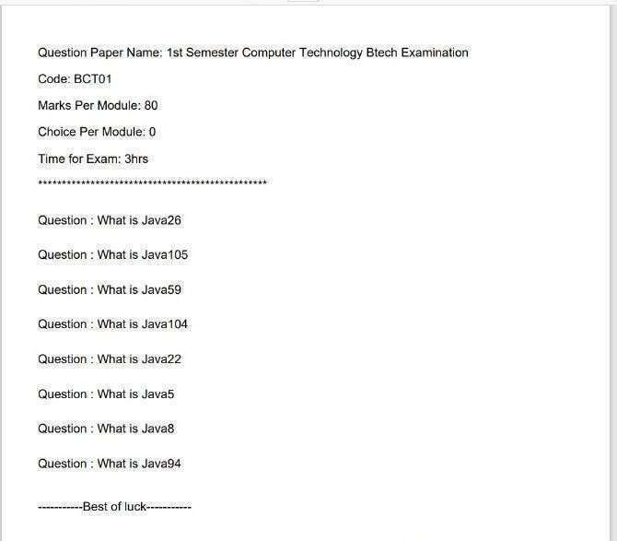

Fig 7.5 Generation of question paper

To categorize questions based on complexity, the Difficulty of Question field features a dropdown menu. This menu provides predefined difficulty levels, such as Easy, Medium, and Hard, enabling educators to tailor assessments to specific learning objectives. The Module field allows users to select the relevant module or topic, ensuring questions align with curriculum requirements. This unique identifier ensures each question is distinguishable within the bank. The "Your Question" field is where users input the actual question. This text field accommodates various question formats, including multiple-choice, true/false, and open-ended questions. This field helps create targeted assessments and supports curriculum alignment. The Semester field specifies the academic level or semester, enabling educators to create assessments tailored to specific stages of student progression. This field ensures questions align with curriculum requirements and learning outcomes. The Subject field enables users to select the discipline or area of study related to the question. This field provides essential context, supporting interdisciplinary connections and fostering a holistic approach to education.

The Branch field allows users to specify the branch of study for which the question is intended. This field enhances question categorization, facilitating search, retrieval, and analysis. Upon completing the form, clicking the Submit button saves the question to the database, making it available for future use. The form's structured design ensures efficient question management, streamlining the process of creating comprehensive question papers. Overall, the "Add Question" web page provides a straightforward and user-friendly interface for adding new questions to a question bank. By leveraging dropdown menus and automated question IDs, the page minimizes errors and enhances data integrity, supporting effective assessment and instruction. Layout and Design is the question paper should have a clean and organized layout, making it easy for students to read and understand. Key Elements is Question Paper Title , Question Paper Code/ID , Instructions for Students, Section/Module Headings , Question Numbers and Text , Answer Spaces (if applicable) , Page Numbers. Formatting is Font: Clear, readable font (e.g., Arial, Times New Roman) ,Font Size: 12-point for question text, 14-point for headings ,Margins: Adequate margins (1-2 inches) for notes and binding ,Alignment: Left-aligned text, centered headings. Organization is Sections/Modules clearly defined

, Questions logically ordered (e.g., easy to hard) ,Answer spaces adequately sized .Visual Hierarchy is Headings and subheadings distinguishable , Important information highlighted (e.g., bold, italic) ,White space effectively used to reduce clutter.

Accessibility is Font and color choices consider color blindness and visual impairments

, Clear instructions for students with disabilities.

Digital Presentation is PDF or online format for easy sharing and access , Navigation tools (e.g., bookmarks, thumbnails) ,Search functionality . Best Practices is Consistency throughout the question paper Proofreading for errors and clarity ,Pilot testing for usability and accessibility. Effective question paper presentation enhances the assessment experience for students. A welldesigned layout helps students focus on the questions, reducing anxiety and stress. Clear instructions and section headings ensure students understand the assessment format and requirements. A visually appealing question paper promotes engagement and motivation. Consistent formatting, adequate white space, and clear typography facilitate easy reading and comprehension. Strategic use of headings, subheadings, and highlighting emphasizes important information, guiding students through the assessment. Digital question paper presentation offers additional benefits. Formats enable interactive features, such as navigation tools, search

functionality, and automatic scoring. Online platforms also facilitate accessibility accommodations, like text-tospeech functionality and zoom options. Moreover, digital question papers reduce printing and distribution costs, supporting sustainable practices

. To further enhance question paper presentation, educators can leverage multimedia elements and interactive features. Incorporating images, diagrams, charts, and graphs can illustrate complex concepts and make questions more engaging. Audio and video clips can also be used to present scenarios or case studies, assessing students' critical thinking and problem-solving skills. Digital question paper formats offer numerous benefits, including interactive features that enhance the assessment experience. These features include:

* Navigation tools for easy question navigation
* Search functionality for quick access to specific questions
* Automatic marking for instant results

The "Add Question" web page provides a user-friendly interface for adding new questions to a question bank. By leveraging dropdown menus and automated question IDs, the page minimizes errors and enhances data integrity, supporting effective assessment and instruction. A well-designed question paper should have a clean and organized layout, making it easy for students to read and understand. Essential elements include the question paper title, code/ID, instructions for students, section/module headings, question numbers and text, answer spaces (if applicable), and page numbers. Proper formatting is crucial, with clear, readable fonts like Arial or Times New Roman. Font sizes should be 12-point for question text and 14-point for headings. Adequate margins (1-2 inches) allow for notes and binding, while left-aligned text and centered headings enhance readability. Effective organization involves clearly defining sections/modules, logically ordering questions (e.g., easy to hard), and sizing answer spaces adequately. A visual hierarchy should be maintained by distinguishing headings and subheadings, highlighting important information (e.g., bold, italic), and utilizing white space to reduce clutter.

## Database

This is an interface for adding questions to a question bank. The user can enter the question, select the difficulty level, the module, semester, subject, and branch the question belongs to. After filling in the details, the user can click "Submit" to add the question to the bank. The image shows a form for adding a new question. The form has fields for the question ID, the question itself, the difficulty level, the module, the semester, the subject, and the branch. The form also has a submit button. The form is likely part of a web application for creating and managing question banks. The application could be used by educators or test administrators to create and administer tests or quizzes.

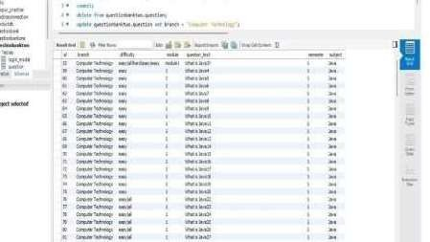

Fig 7.6 Database

The Blurriness of the image suggests that the form was captured from a computer screen. This is common for screenshots of web pages or other software interfaces. Overall, the image provides a glimpse into a system for managing questions and tests, highlighting the importance of clear and concise information presentation in such systems. The Interface Overview is a web-based form for adding questions to a question bank. It enables users (likely educators or test administrators) to create and manage questions for assessments. Form Fields is Question ID (auto-generated or manual input), Question (text area for entering the question),Difficulty Level (dropdown menu) ,Module and or

(dropdown menu), Semester (dropdown menu) , Subject (text field), Branch (text field) . Submit Button has Clicking "Submit" adds the question to the question bank. This interface is likely part of a larger web application for Creating and managing question banks, developing assessments (tests, quizzes, exams), Administering tests to students . Target Users has Educators, Test administrators, Instructors. And The Key Features is Organized question management, Categorized question storage (difficulty, module, semester, subject, branch), Easy question addition and submission .Technical Details is Web-based interface , Likely built using HTML, CSS, JavaScript, May integrate with databases for question storage and retrieval. Potential Future Developments is Enhanced search and filtering functionality, Collaborative question editing and review tools , Integration with learning management systems (LMS), Support for multimedia question types, Advanced analytics and reporting features. The displayed interface facilitates adding questions to a question bank. Users input the question text, select the difficulty level, and categorize it by module, semester, subject, and branch. After filling in the details, clicking "Submit" adds the question to the bank. The form comprises fields for question ID, question text, difficulty level, module, semester, subject, and branch. This interface is part of a web application for creating and managing question banks, ideal for educators and test administrators to develop and administer quizzes and tests. The underlying database stores question details, enabling efficient retrieval and management. This yield benefits like organized storage and retrieval, easy categorization and filtering, simplified test creation and administration, and enhanced data security and integrity. The application streamlines question bank management, saving time and effort. Its user- friendly interface and robust database ensure a seamless experience for educators and administrators, ultimately enhancing the assessment process. This data is then indexed for quick search and retrieval and protected through secure authentication and access controls. The question becomes part of the comprehensive question bank. Educators can now create customized assessments, track student performance, and refine curriculum and instruction using this database. Alao the

The submitted question enhances the assessment process. The database update enables efficient management, retrieval, and analysis of questions, supporting effective instruction and student success. The database's robust architecture facilitates seamless integration with other educational tools and platforms. This enables a holistic approach to assessment and instruction. With the question bank's scalable design, educators can

easily manage large collections of questions. Advanced filtering and search functionalities simplify question retrieval.

**CHAPTER 8**

# CONCLUSION AND FUTURE SCOPE

## Conclusion

In conclusion, in this project, we have successfully developed an Automatic Question Paper Generator System utilizing the Ant Colony Optimization (ACO) algorithm. The future of automated question paper generation systems promises transformative advancements through the integration of artificial intelligence, cloud computing, and blockchain technology. These intelligent systems will revolutionize exam creation by enabling dynamic question generation from diverse educational materials, automatic difficulty adjustment based on performance analytics, and seamless multilingual support to accommodate global education needs. As these technologies mature, they will fundamentally reshape assessment methodologies, creating more efficient, adaptive, and equitable examination systems. The convergence of AI-powered automation with robust security measures and inclusive language capabilities positions these systems to become indispensable tools in modern education, offering unprecedented levels of customization, reliability, and accessibility for institutions across the globe. The evolution of automated question paper generation systems represents a paradigm shift in educational assessment methodologies. By harnessing cutting-edge technologies like artificial intelligence and machine learning, these systems are poised to fundamentally transform how examinations are created, administered, and evaluated. The integration of sophisticated natural language processing enables dynamic question generation from diverse source materials, while adaptive algorithms ensure optimal difficulty levels tailored to specific learning outcomes. Cloud-based architectures facilitate seamless collaboration across institutions, breaking down geographical barriers and fostering global educational standards. Blockchain implementations provide an immutable audit trail, safeguarding the integrity of examination materials and preventing unauthorized access. Multilingual capabilities coupled with voice recognition interfaces democratize access, making these systems truly inclusive for diverse linguistic communities. As these technologies continue to mature, they promise to deliver unprecedented levels of efficiency, personalization, and security in assessment processes. The convergence of these innovations will not only streamline administrative workflows but also enhance the validity and reliability of evaluations, ultimately contributing to more equitable and effective learning ecosystems worldwide.

This technological revolution in assessment tools stands to redefine educational paradigms, offering scalable solutions that adapt to the evolving needs of 21st-century learners and educators alike. The future of automated question paper generation systems promises transformative advancements through the integration of artificial intelligence, cloud computing, and blockchain technology. These intelligent systems will revolutionize exam creation by enabling dynamic question generation from diverse educational materials, automatic difficulty adjustment based on performance analytics, and seamless multilingual support to accommodate global education needs. Cloud-based platforms will facilitate real-time collaboration among educators worldwide while maintaining rigorous security through blockchain implementations that prevent leaks and ensure question integrity. As these technologies mature, they will fundamentally reshape assessment methodologies, creating more efficient, adaptive, and equitable examination systems. The convergence of AI-powered automation with robust security measures and inclusive language capabilities positions these systems to become indispensable tools in modern education, offering unprecedented levels of customization, reliability, and accessibility for institutions across the globe. The system addresses several challenges faced in traditional methods of question paper generation, such as time inefficiency, human bias, and the difficulty of ensuring balanced and diverse question selection.

By applying a nature-inspired optimization technique, the system automates the selection of questions from a large question bank, ensuring that each paper meets predefined criteria regarding difficulty levels, topic coverage, and variety. The implementation of the Ant Colony Optimization ACO algorithm allows the system to continuously improve the quality of generated question papers through iterations, much like how real ants optimize their search for food. The system not only reduces the manual effort involved but also ensures fairness and scalability, making it an ideal solution for academic institutions handling a wide range of subjects and branches. By integrating the Ant Colony Optimization ACO algorithm, this project demonstrates how bio-inspired algorithms can be applied to solve practical, real-world problems efficiently. The system's ability to generate multiple, well- structured question papers in a fraction of the time required by traditional methods highlights its potential for widespread use. Additionally, this project provides a foundation for future enhancements, such as incorporating additional constraints or extending the algorithm to handle more complex requirements .

## Limitation of study

* + - The Automatic Question Paper Generator System using Ant Colony Algorithm has several limitations that affect its overall functionality and effectiveness. One of the main limitations are its dependence on the quality of the input data. The algorithm’s performance is heavily reliant on a well-balanced and diverse question bank. If the question bank lacks sufficient questions for specific difficulty levels or topics, the generated question paper may not meet user expectations.
    - Additionally, the Ant Colony Algorithm Generator System may converge prematurely to suboptimal solutions if early pheromone updates heavily influence subsequent selections, making it difficult to explore better solutions.
    - This challenge is compounded by the need for careful parameter tuning, such as the values for alpha and beta, which control the balance between pheromone influence and question difficulty.
    - The Automatic Question Paper Generator System employing Ant Colony Optimization (ACO) demonstrates several significant limitations that affect its practical implementation and educational effectiveness. The system's performance is fundamentally constrained by the quality and comprehensiveness of its underlying question bank, as inadequate representation of questions across difficulty levels or topics frequently results in suboptimal paper generation.
    - Algorithmically, the solution suffers from premature convergence to local optima due to disproportionate early pheromone accumulation and requires meticulous parameter tuning of α and β coefficients to properly balance exploration versus exploitation. As the question bank grows, computational complexity escalates non-linearly, creating serious scalability challenges, while pheromone stagnation often leads to redundant question selection in successive iterations.
    - From a pedagogical perspective, the system's narrow optimization focus on difficulty balancing frequently comes at the expense of comprehensive topic coverage and lacks mechanisms to ensure proper alignment with broader curriculum objectives. The evaluation methodology remains oversimplified, focusing primarily on difficulty matching while neglecting crucial factors like question relevance and educational value.
    - Operational constraints further limit the system's utility, as dynamic updates to the question bank necessitate complete pheromone reinitialization, and the absence of real-time user intervention capabilities during the generation process reduces flexibility. Additionally, the resource-intensive nature of the algorithm restricts deployment on constrained hardware environments commonly found in educational institutions.
    - These limitations collectively highlight the need for substantial improvements, particularly in developing more sophisticated evaluation criteria, implementing dynamic parameter adjustment mechanisms, and potentially incorporating hybrid optimization approaches or machine learning techniques to enhance the system's adaptability and educational relevance. Future iterations would benefit from expanding optimization objectives to encompass a more comprehensive set of pedagogical considerations while maintaining the algorithm's core advantages in automated question selection.
    - Achieving this balance can be difficult and time-consuming. Furthermore, the algorithm becomes computationally intensive with larger question banks, increasing the time and resources required to generate an optimal solution. This high computational cost may limit the system’s scalability for very large datasets.
    - The simplistic evaluation methodology, which primarily counts questions that match difficulty requirements, does not account for other factors such as question relevance or educational value, potentially leading to suboptimal outcomes. Finally, the lack of real-time interaction limits the user’s ability to adjust the generated paper, making it less flexible for users who may want to refine the output manually.
    - The Automatic Question Paper Generator System using Ant Colony Algorithm has several limitations that affect its overall functionality and effectiveness. One of the main limitations are its dependence on the quality of the input data. The algorithm’s performance is heavily reliant on a well-balanced and diverse question bank. If the question bank lacks sufficient questions for specific difficulty levels or topics, the generated question paper may not meet user expectations.

## Future scope

The Automatic Question Paper Generator System using Ant Colony Algorithm has significant potential for further development and enhancements. Some possible future scopes for the project include:

* + The Automatic Question Paper Generator System using Ant Colony Optimization (ACO) has significant potential for future enhancements that could transform it into a more sophisticated and comprehensive assessment solution. One promising direction involves integrating advanced artificial intelligence techniques with the existing ACO framework.
  + Machine learning algorithms could be employed to dynamically optimize the ACO parameters based on historical performance data, while natural language processing could enable automated question generation and quality assessment.
  + The system could also benefit from incorporating neural networks to predict optimal question combinations by analyzing patterns in past question papers. From a pedagogical perspective, future developments should focus on better aligning the system with educational objectives through features like curriculum mapping, learning outcome-based question tagging, and adaptive difficulty adjustment based on student performance analytics.
  + Technical improvements could include developing hybrid optimization approaches that combine ACO with other metaheuristic algorithms, creating distributed computing architectures to handle large-scale question banks, and implementing more efficient pheromone update mechanisms.
  + The user experience could be significantly enhanced through interactive interfaces for real-time paper customization, collaborative features for multi-educator paper creation, and mobile applications for increased accessibility. Expanding the system's assessment capabilities to include automated evaluation of subjective answers, support for multimedia questions, and advanced randomization algorithms would make it suitable for a wider range of testing scenarios.
  + Finally, institutional integration features like LMS connectivity, analytics dashboards, and question sharing platforms could facilitate broader adoption across educational organizations. These future developments would collectively elevate the system from a specialized question paper generator to a comprehensive, intelligent assessment platform capable of meeting diverse educational needs while maintaining the core benefits of automated, optimized question selection.
  + Expansion of Question Bank: The system can be extended to support larger and more diverse question banks, covering multiple subjects, branches, and educational levels. By integrating more varied content, the system could be adapted for use across a wide range of academic fields, from primary to higher education.
    - Integration with Learning Management Systems (LMS): The system can be integrated with popular learning management systems (LMS) to streamline the process of paper generation, scheduling, and distribution. This would make the system more accessible and user-friendly for educational institutions and allow for automatic grading and feedback features.
    - Adaptive Learning: The system could evolve to include personalized question papers based on a student's learning progress and performance history. This would enable the generation of question sets that are tailored to individual learning needs, reinforcing weak areas and challenging stronger skills.
    - Multi-language Support: Adding multi-language support would enable the system to cater to educational institutions in different regions and countries. By expanding language options, the system could be adopted globally, making it more versatile and widely usable.
    - Cloud-based Implementation: The system could be developed into a cloud-based platform, allowing multiple users and institutions to access it remotely and scale its functionality across different geographies. This would also improve collaboration between educators in different regions.
    - Automated Grading: Future developments could include features for automated grading, allowing the system to generate question papers, administer tests, and evaluate student responses autonomously. This would provide a comprehensive solution for examination management.
    - These advancements would position the system at the forefront of educational innovation, capable of supporting next-generation learning paradigms while maintaining academic rigor and integrity. Ultimately, the future of automated question generation lies in creating dynamic, intelligent systems that adapt to both institutional requirements and individual learner needs, thereby redefining the very nature of educational assessment in the digital age.

# References

1. Aditya Sanjay Shendure1, Mr. Aniruddh Dagadu Khamkar1, Mr. Prasanna Premnath Vathare, Mr. Avadhut Salavi(Kumbhar) (2022) “Question Paper Generator System”, *International Journal for Research in Applied Science and Engineering Technology (IJRASET),* India.
2. Pranav Thigale, Subodh Nadkar, Baswaraj Kokle, Nagesh Bhole, F.S. Ghodichor( 2021)“Automatic Question Paper Generator System by Keywordbased Shuffling Algorithm”, *International Journal of Advanced Research in Computer and communication Engineering ,*India
3. Gauri Nalawade, Rekha Ramesh(2021)” Automatic Generation of Question Paper from User Entered Specifications using a Semantically Tagged Question Repository”, *International Conference on Technology for Education,* India.
4. Fenil Kiran Gangar, Hital Gopal Gori, Ashwini Dalvi(2017)” Automatic Question Paper Generator System”, *International Journal of Computer Applications*,India*.*
5. Rohan Bhirangi, Smita Bhoi (2016) “Automated Question Paper Generation System”, *International Journal of Emerging Research in Management &Technology*, India.
6. Mr. Mihir Joisher, Mr. Swapnil Ghagare, Ms. Mittal Patel, Mr. Ritesh Rathi.(2016)” Automated Question Paper Generator”, *International Journal on Recent and Innvention Trends in Computing and Communication,* India.
7. Surbhi Choudhary,Abdul Rais Abdul Waheeda, Shrutika Gawandi

,Kavita Joshi.(2015). *International Journal of Computer Science Trends and Technology (IJCST),* India.